

Mawlana Bhashani Science and Technology, Santosh, Tangail

**Department**: Information & Communication Technology

Batch – 18

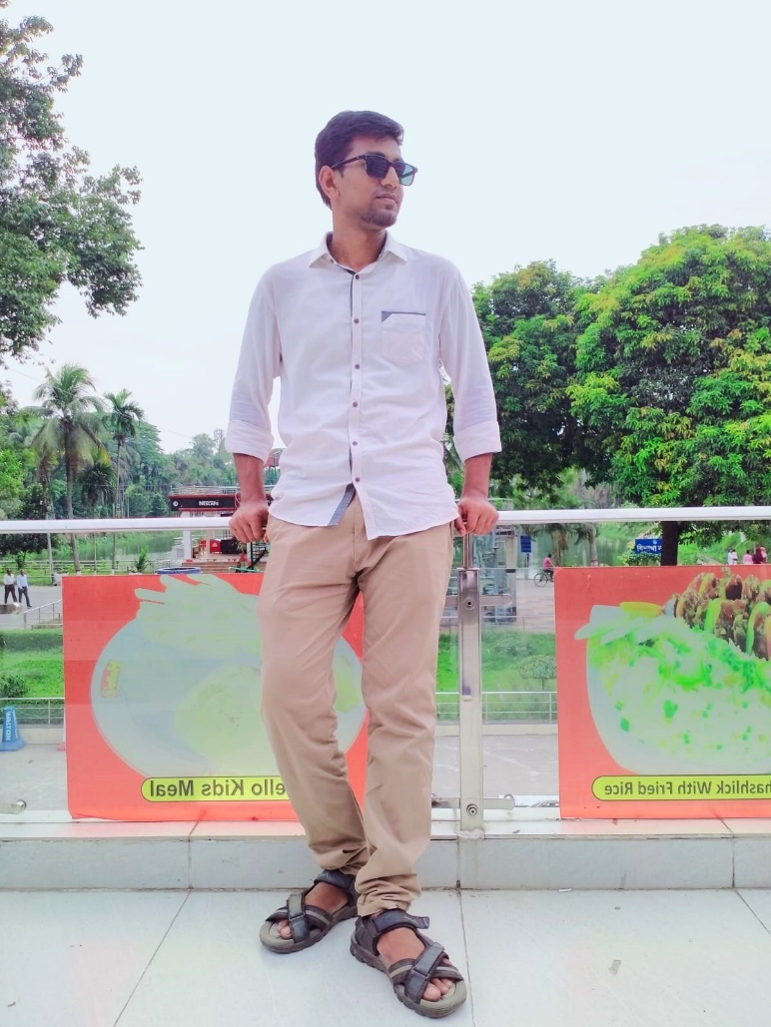

**Name**: Shafi Mahmud bhai

**District**: Mymensingh

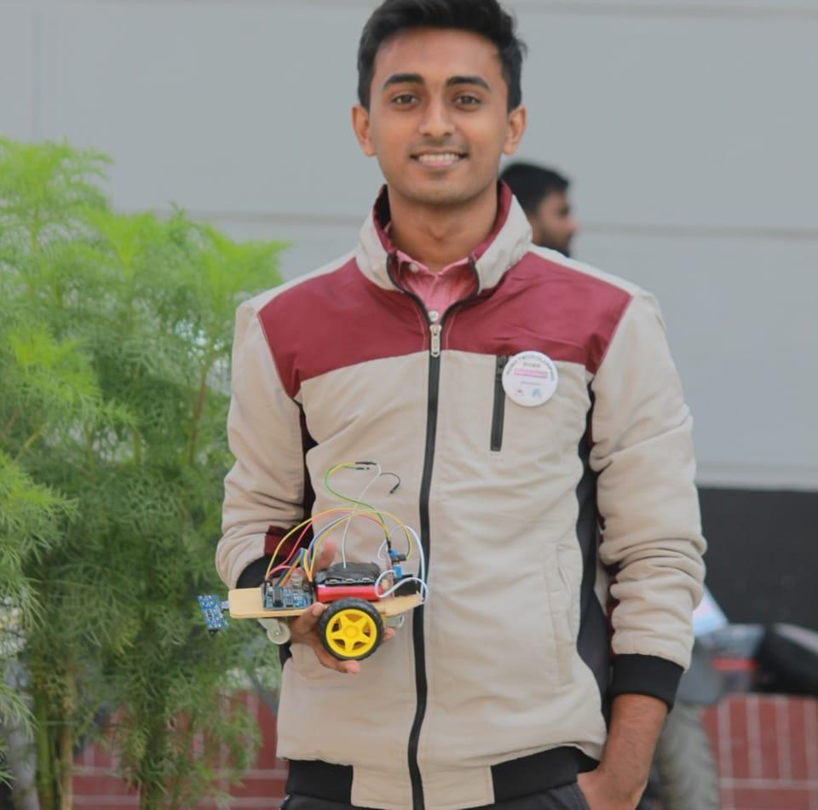

**Name**: Tanvir Islam Tamim bhai

**District**: Barishal

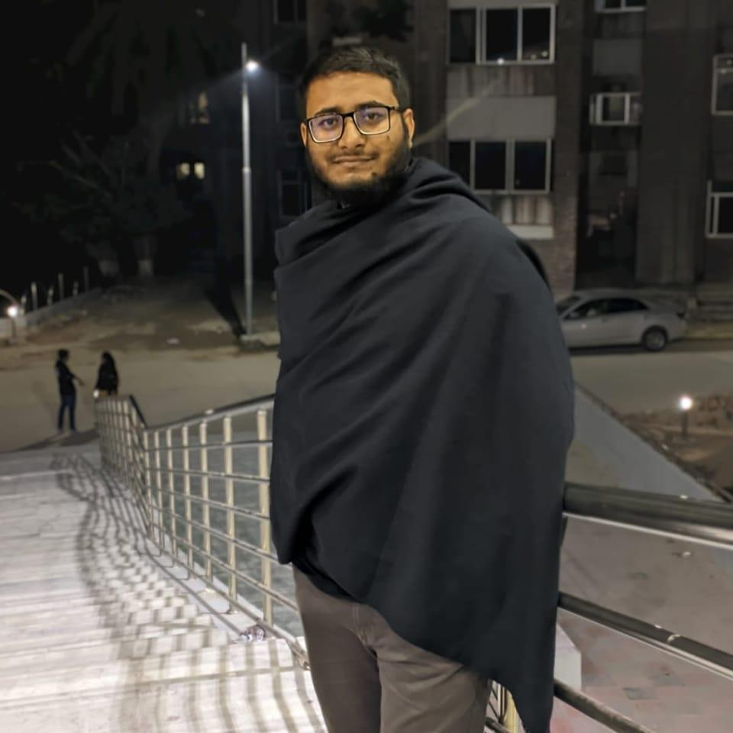

**Name**: Siam Ahmed Ebrahim bhai

**District**: Sirajganj

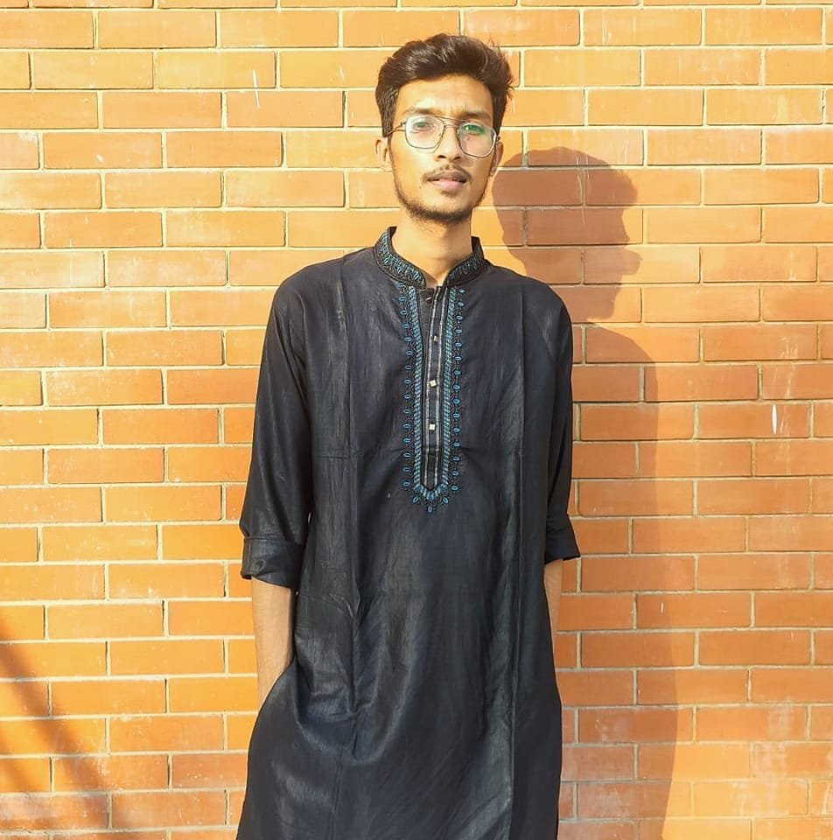

**Name**: Mamun Ahmed bhai

**District**: Tangail

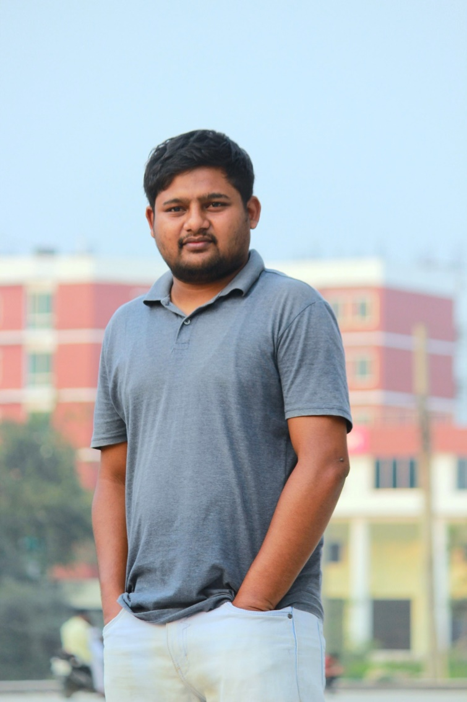

**Name**: Muraduzzaman Murad bhai

**District**: Jamalpur

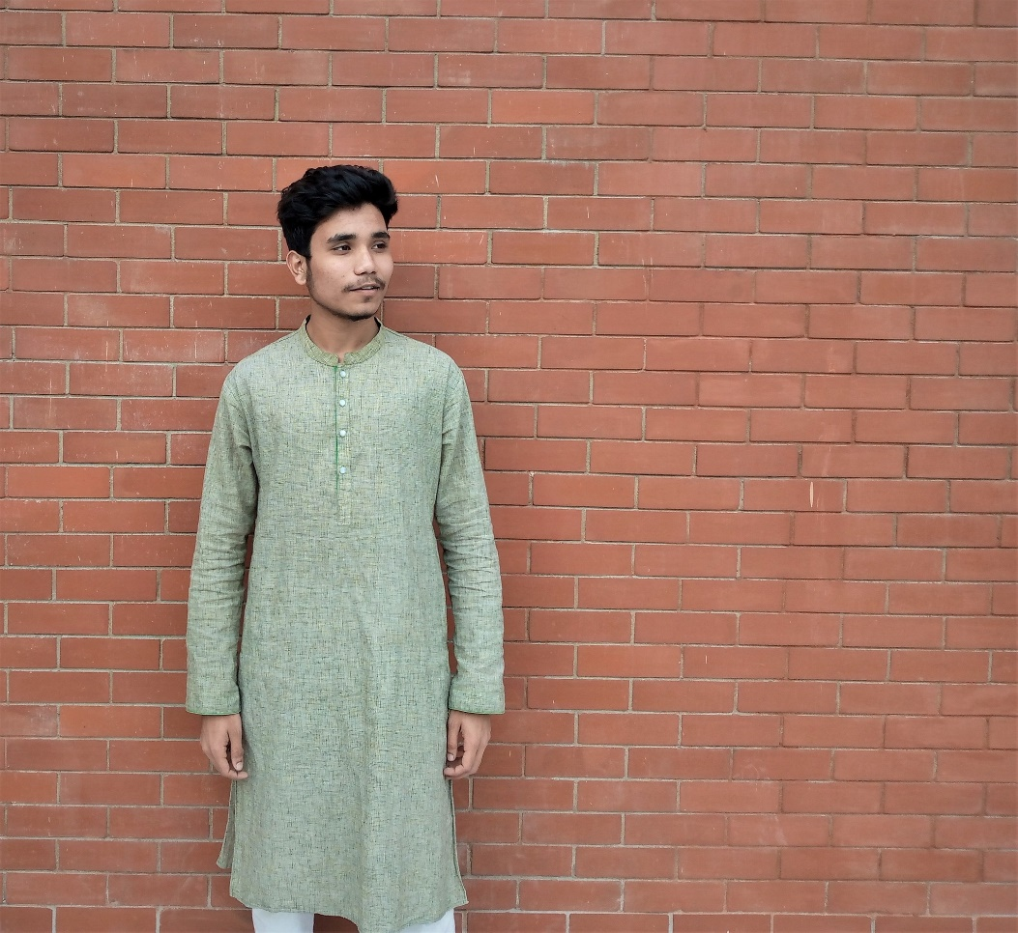

**Name**: Mohammad Burhan bhai

**District**: Jamalpur

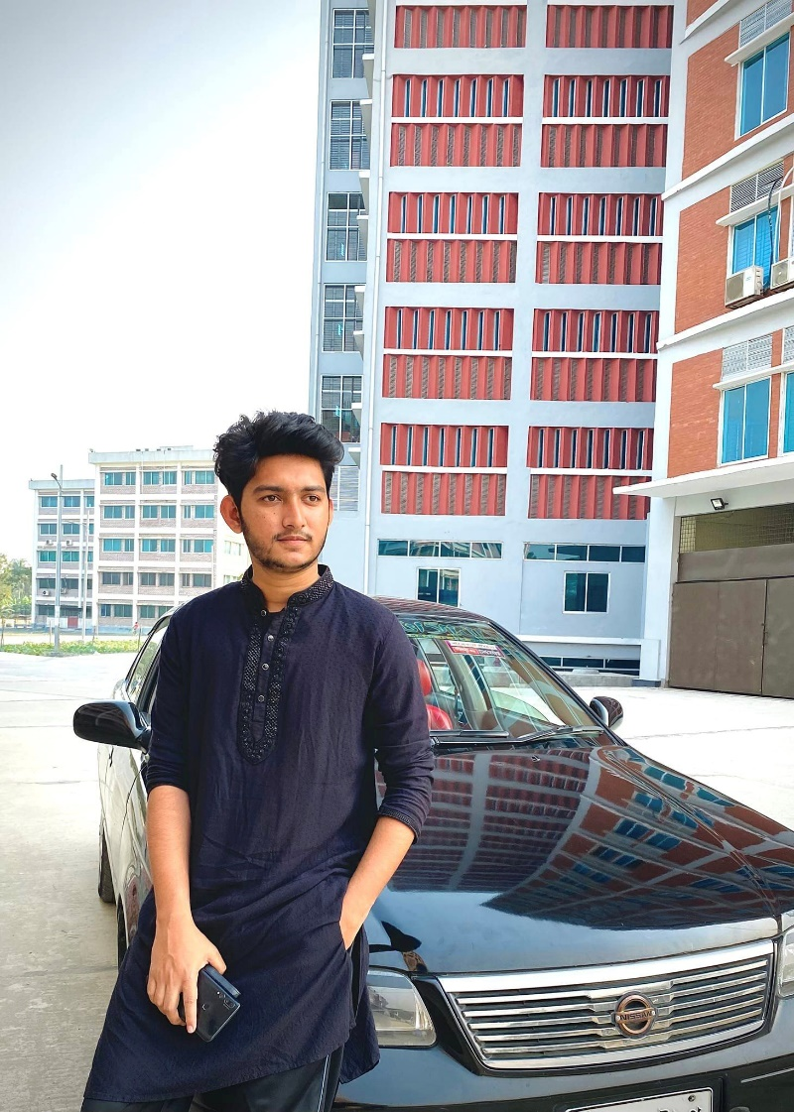

**Name**: Zisun Mirza bhai

**District**: Tangail

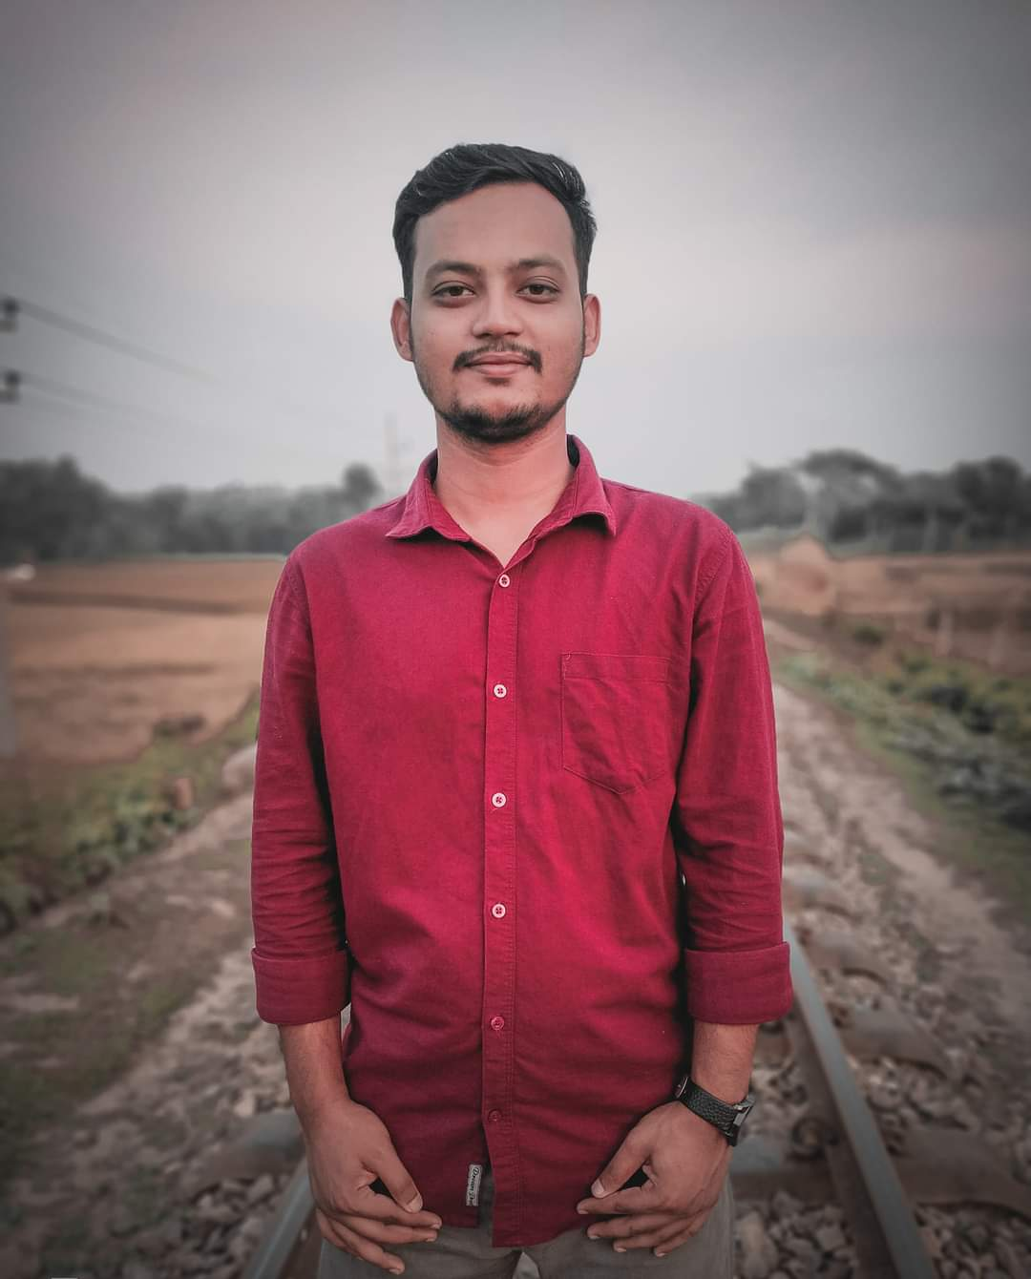

**Name**: Abdur Rahman Bijoy bhai

**District**: Mymensingh

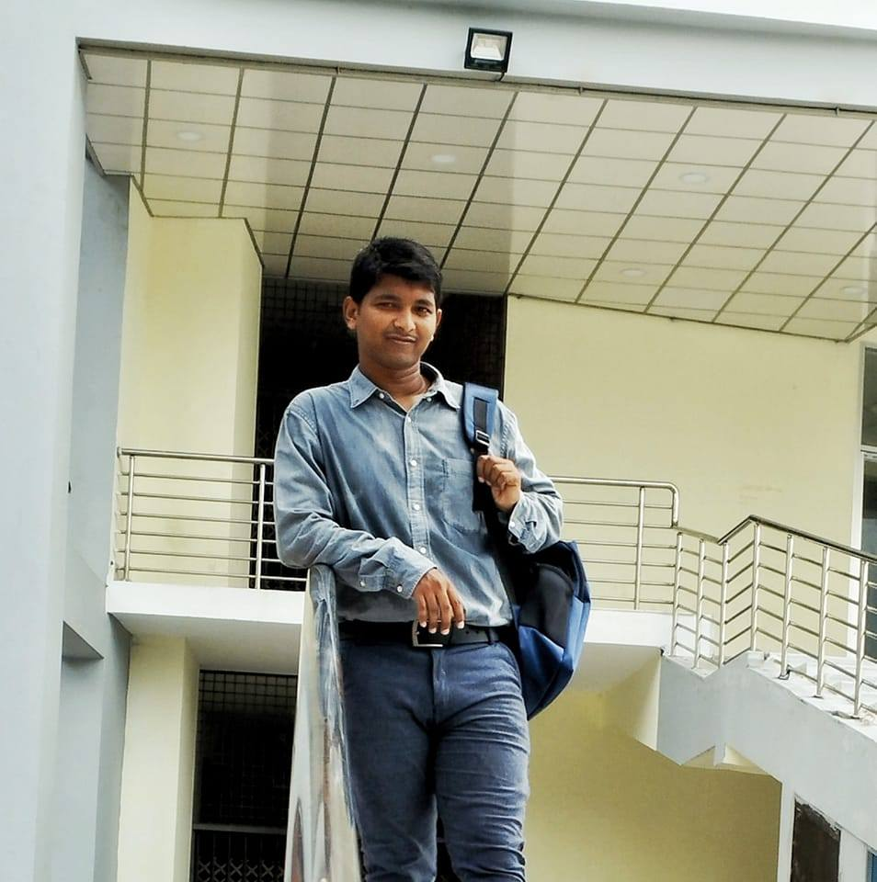

**Name**: Md Ashikujjaman Nur bhai

**District**: Khulna

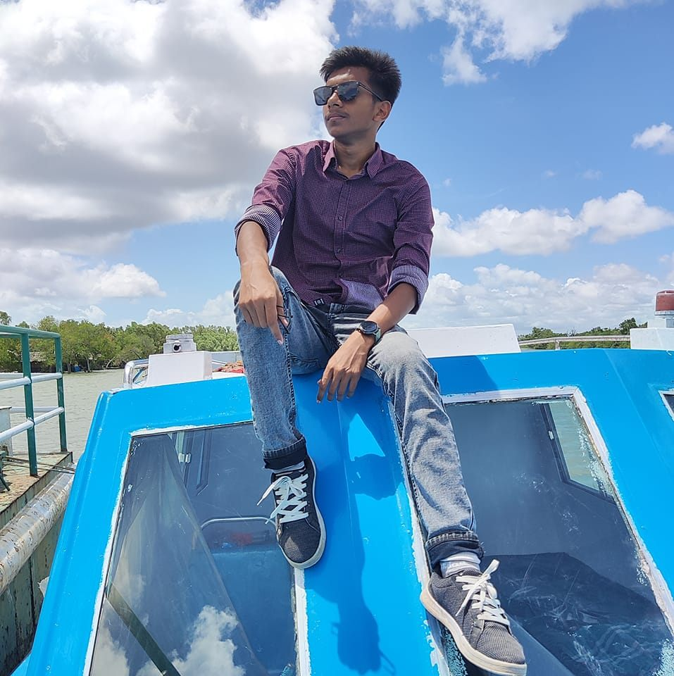

**Name**: Shajib Mohammad bhai

**District**: Khulna

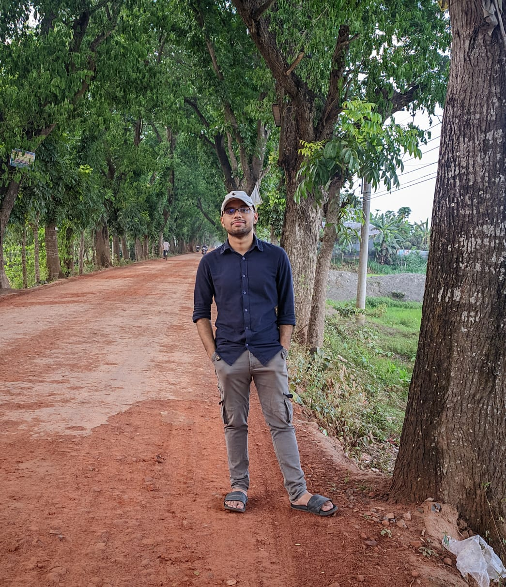

**Name**: Swapnil Saha bhai

**District**: Tangail

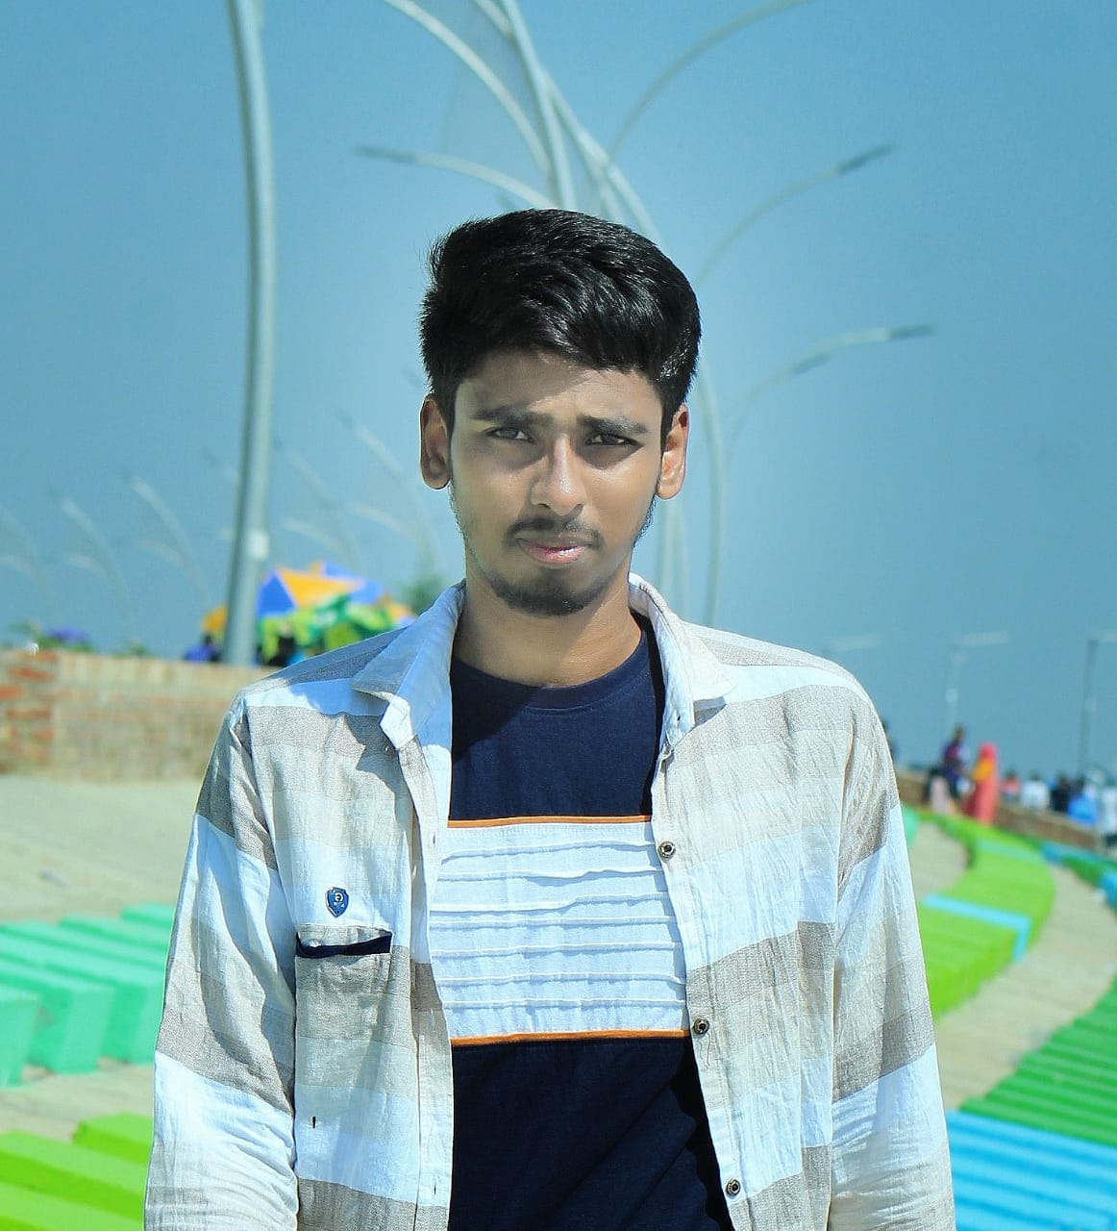

**Name**: ShaKil Khan bhai

**District**: Dhaka

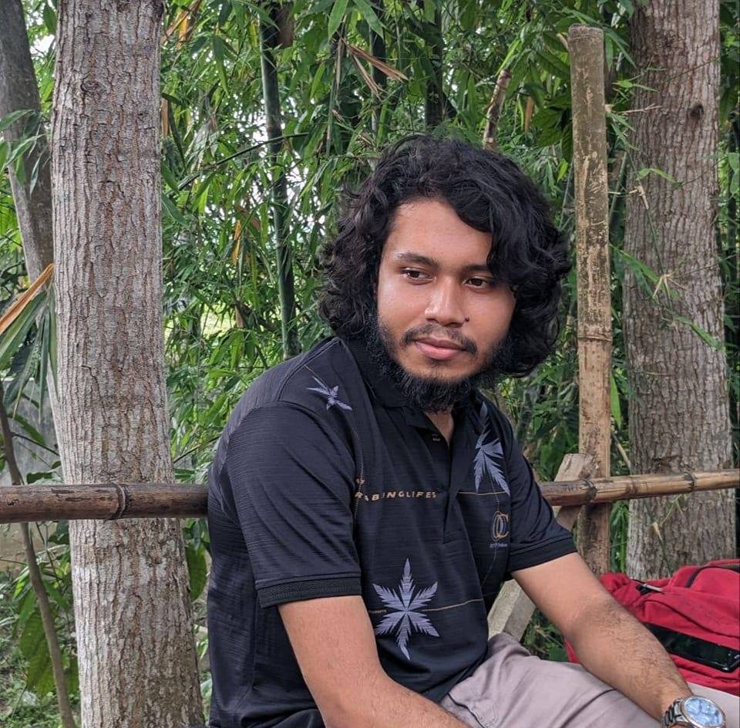

**Name**: Shafiuddin Siyam bhai

**District**: Narayanganj

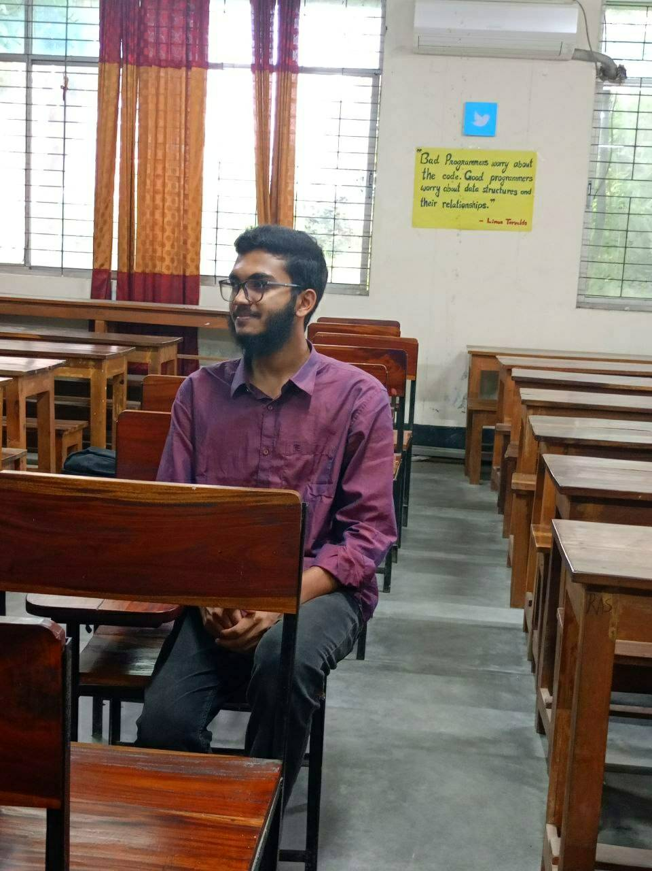

**Name**: Nazibur Rahman bhai

**District**: Jamalpur

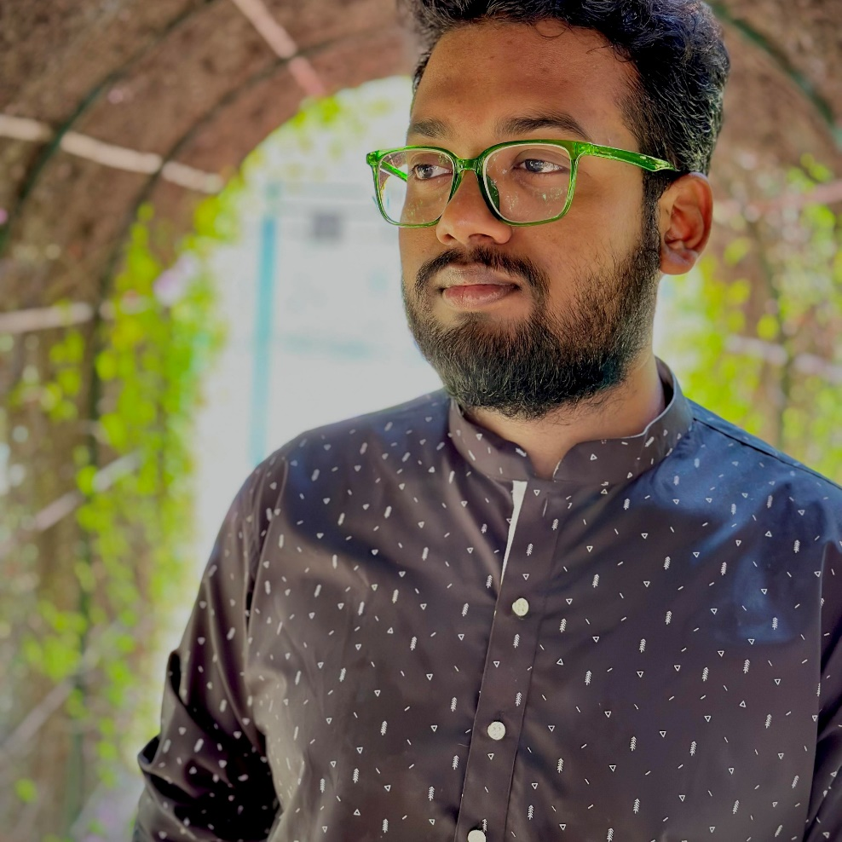

**Name**: Yeasin Arafat Tomal bhai

**District**: Dhaka

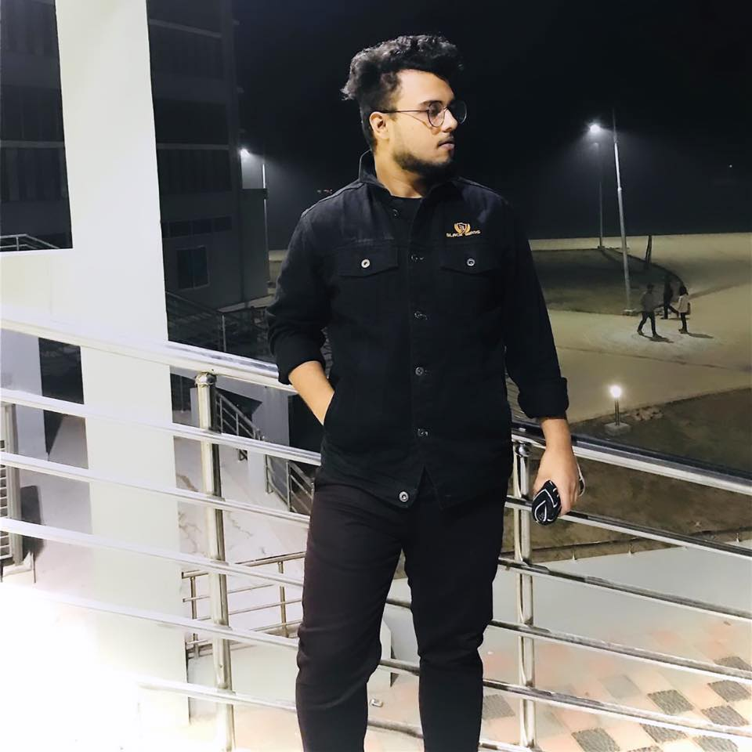

**Name**: Rafi Ahmed Usshas bhai

**District**: Tangail

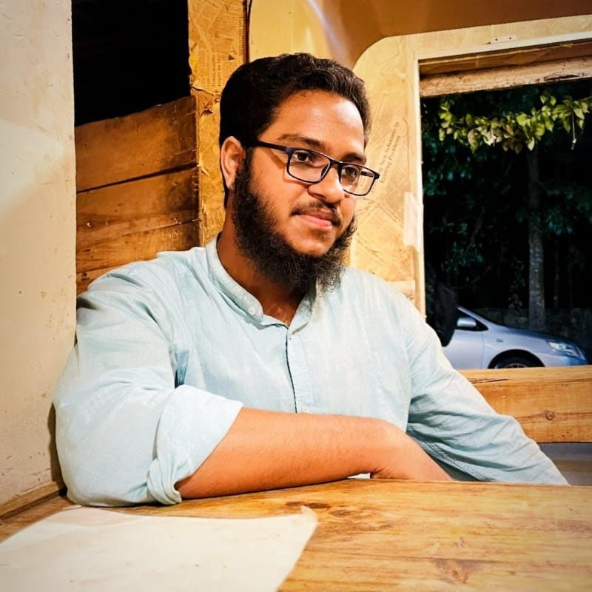

**Name**: Udoy Talukder bhai

**District**: Tangail

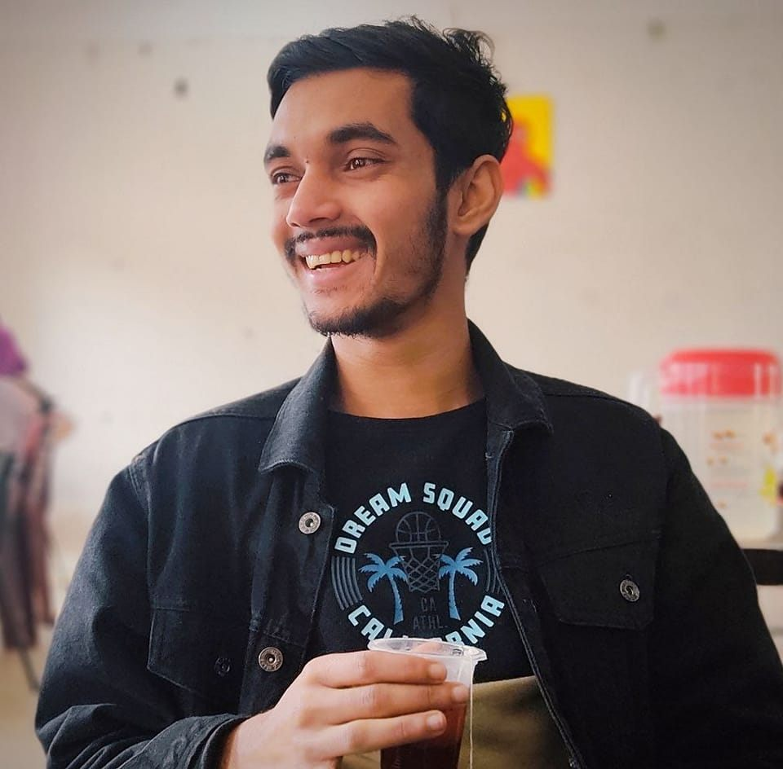

**Name**: Jabir Hossen Nayan bhai

**District**: Tangail



**Name**: Rifat Ullah Khan bhai

**District**: Mymensingh

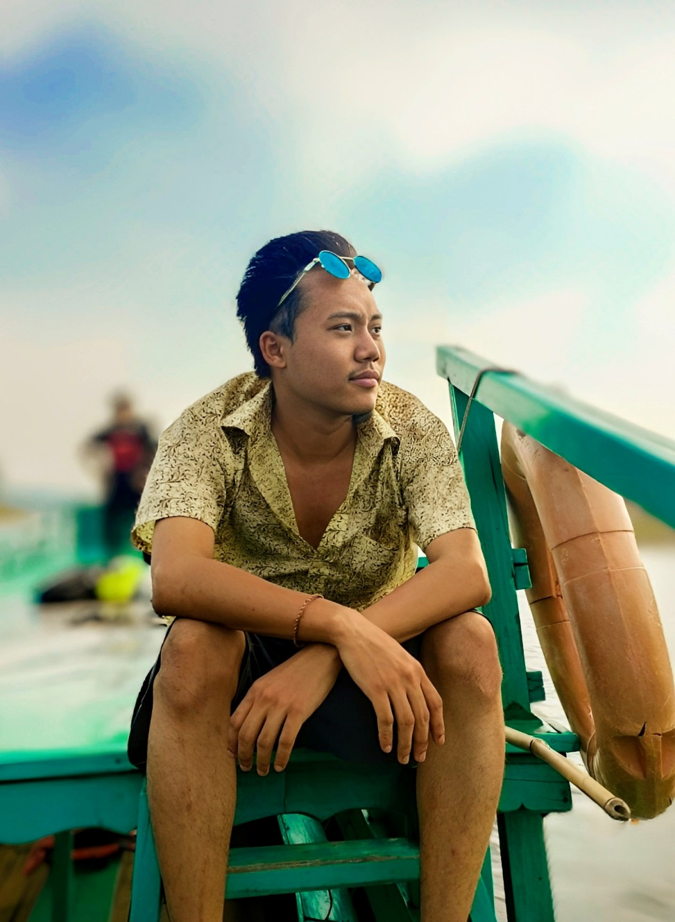

**Name**: Rocktim Chakma bhai

**District**: Rangamati

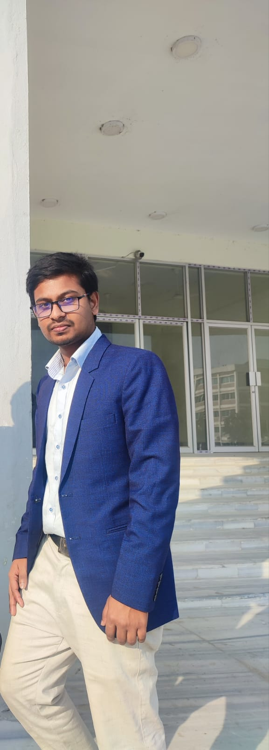

**Name**: Ramprasad Sarkar Antar bhai

**District**: Jamalpur

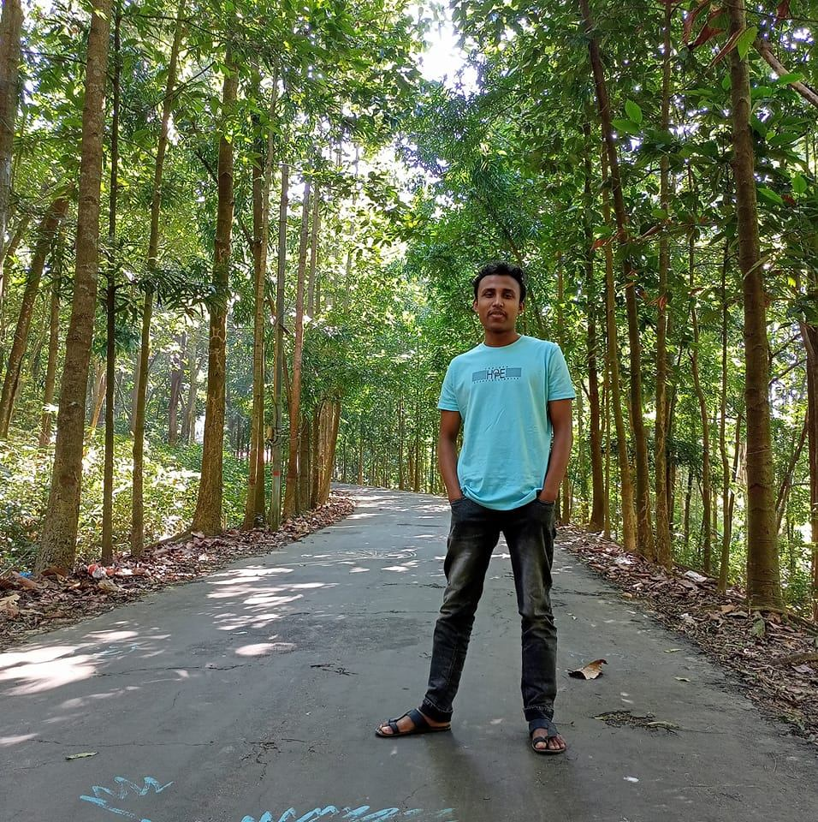

**Name**: Md Fahim bhai

**District**: Comilla

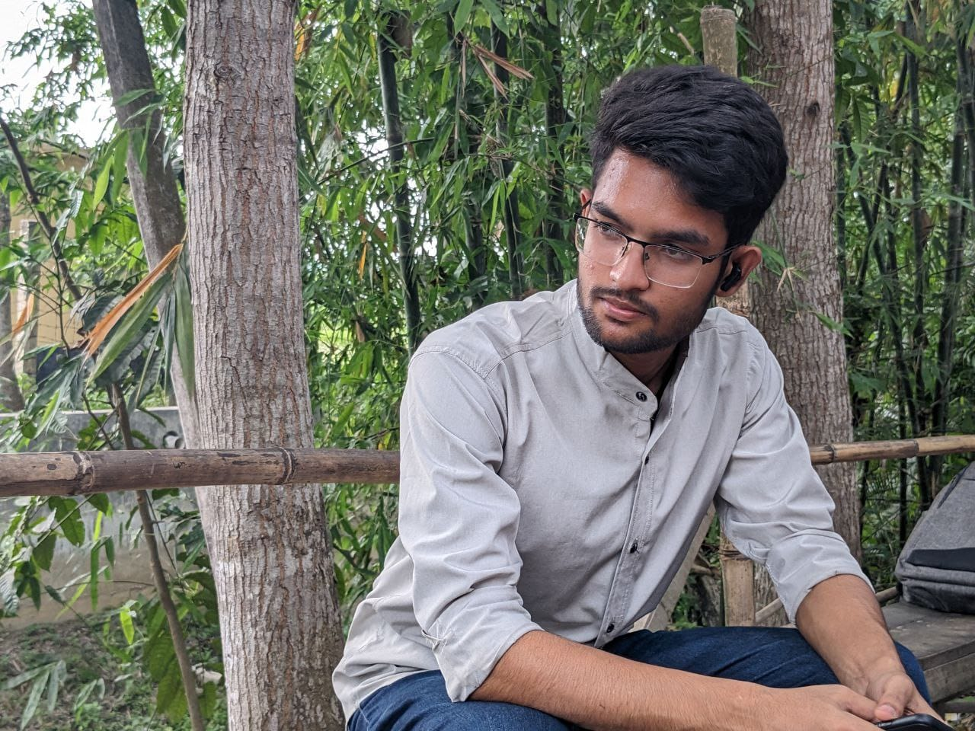

**Name**: Atiqur Rahman Sajib bhai

**District**: Dhaka

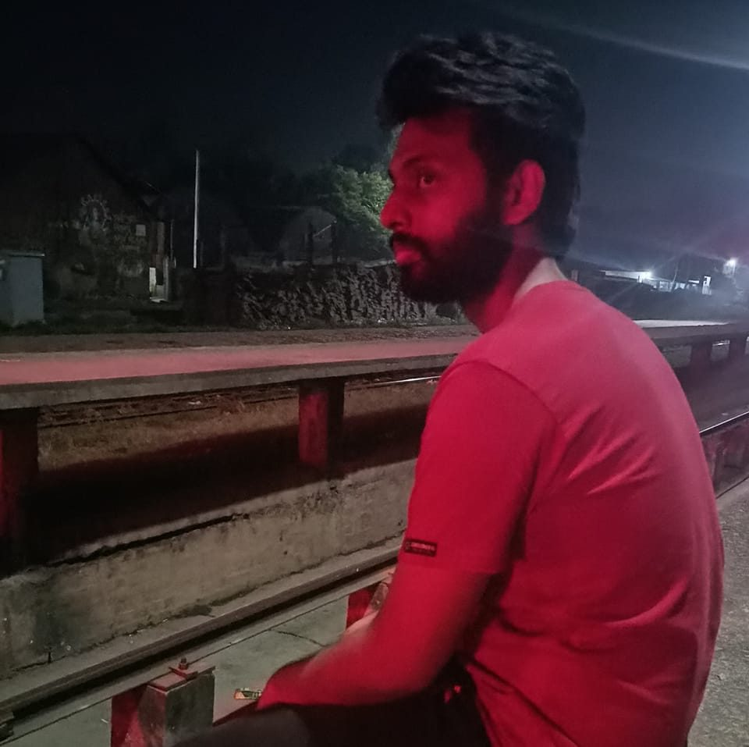

**Name**: Niloy Sarkar Uthso bhai

**District**: Mymensingh

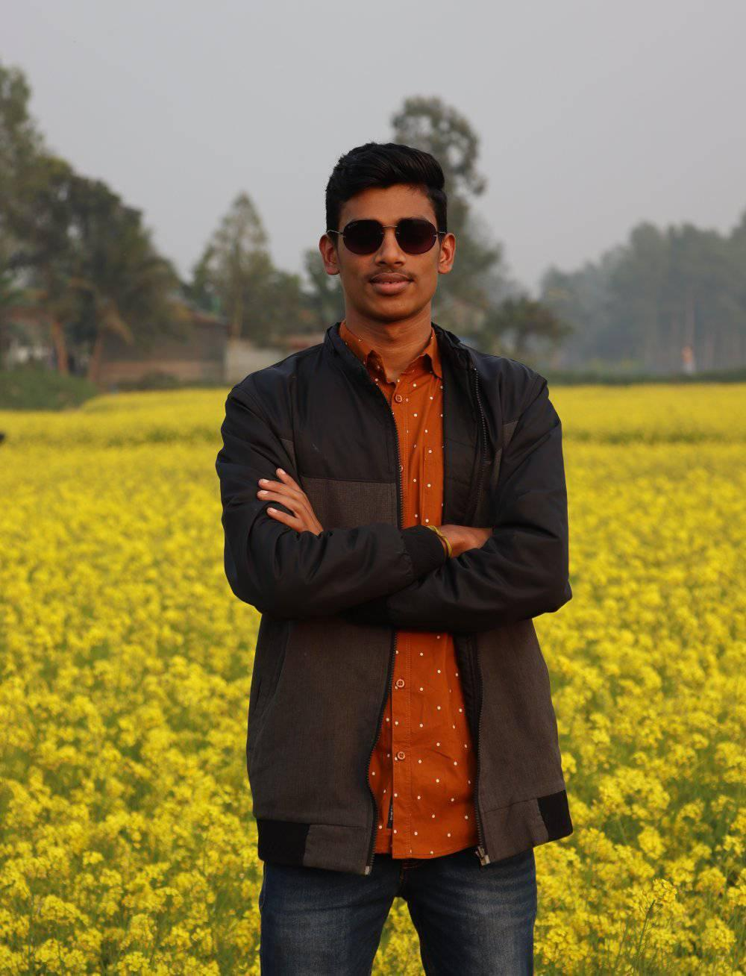

**Name**: Sagor Roy bhai

**District**: Sunamganj

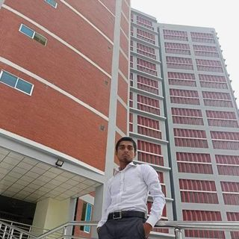

**Name**: Lutfor Rahman bhai

**District**: Brahmanbaria

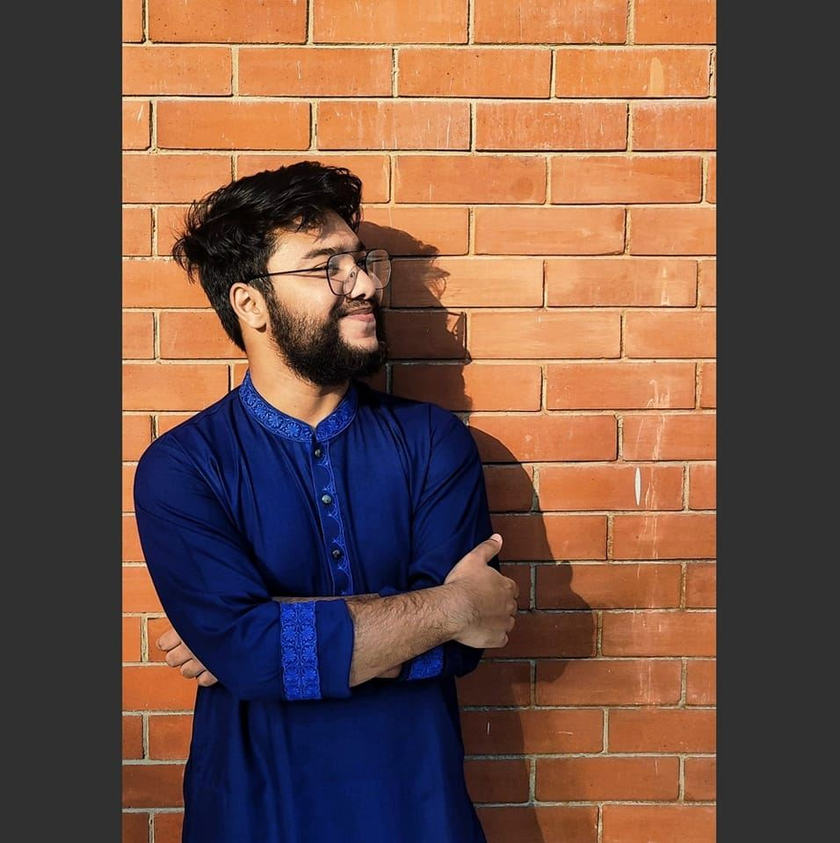

**Name**: Sheikh Muhammed Jisan bhai

**District**: Rajbari

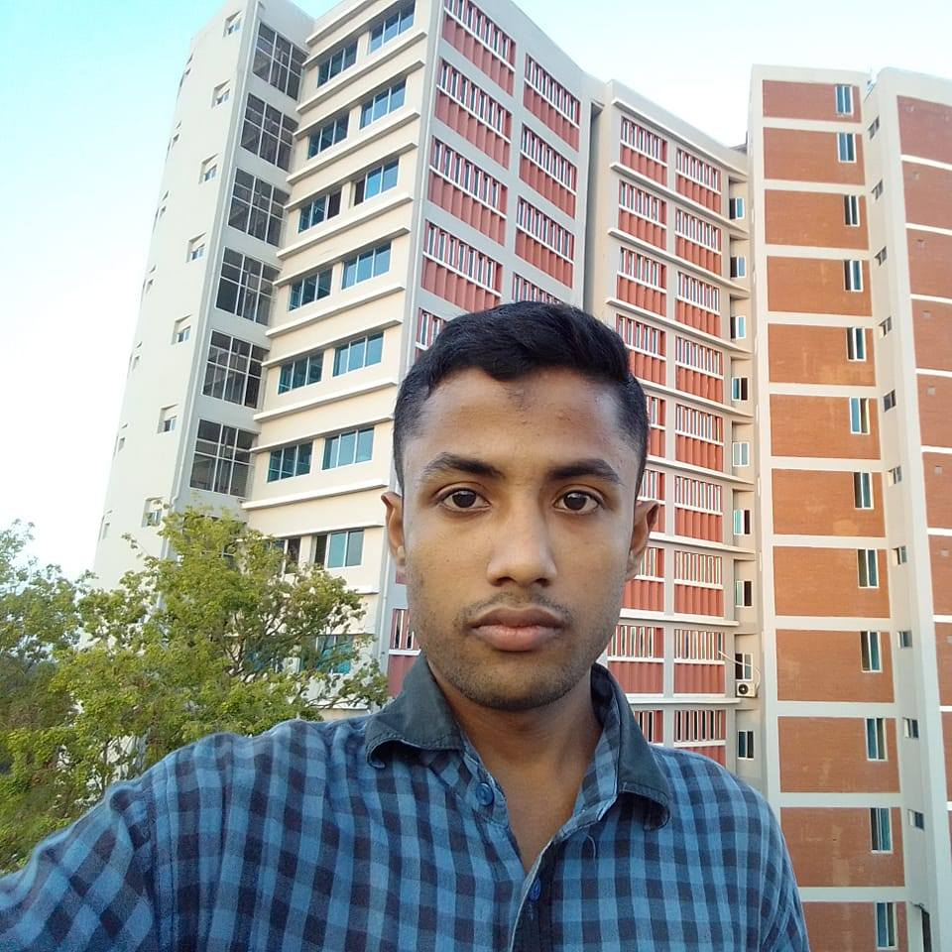

**Name**: Abdus Salam bhai

**District**: Kishoreganj

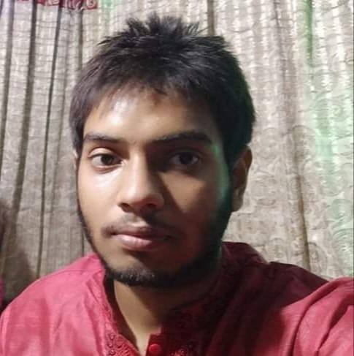

**Name**: Abdul Ahad bhai

**District**: Tangail

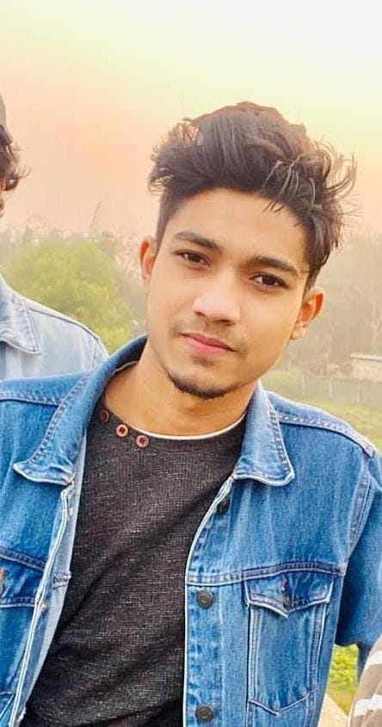

**Name**: Fardin Tanvir bhai

**District**: Jamalpur

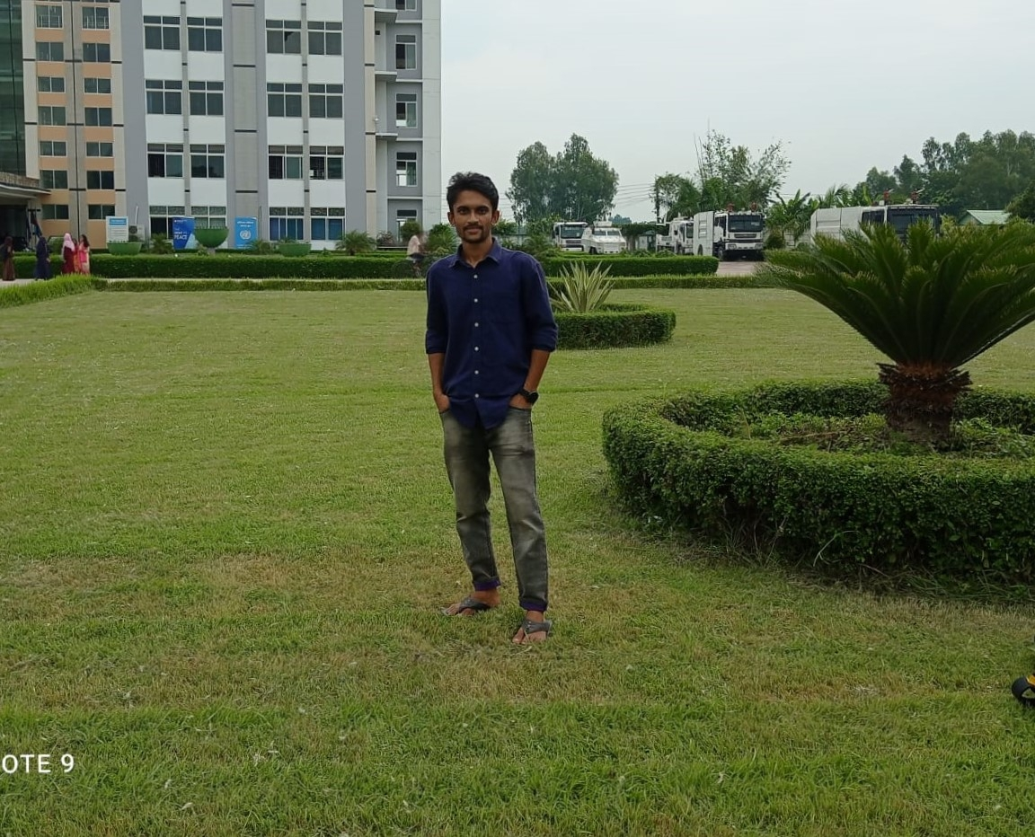

**Name**: Md. Shahidul Islam Shourov bhai

**District**: Bogra

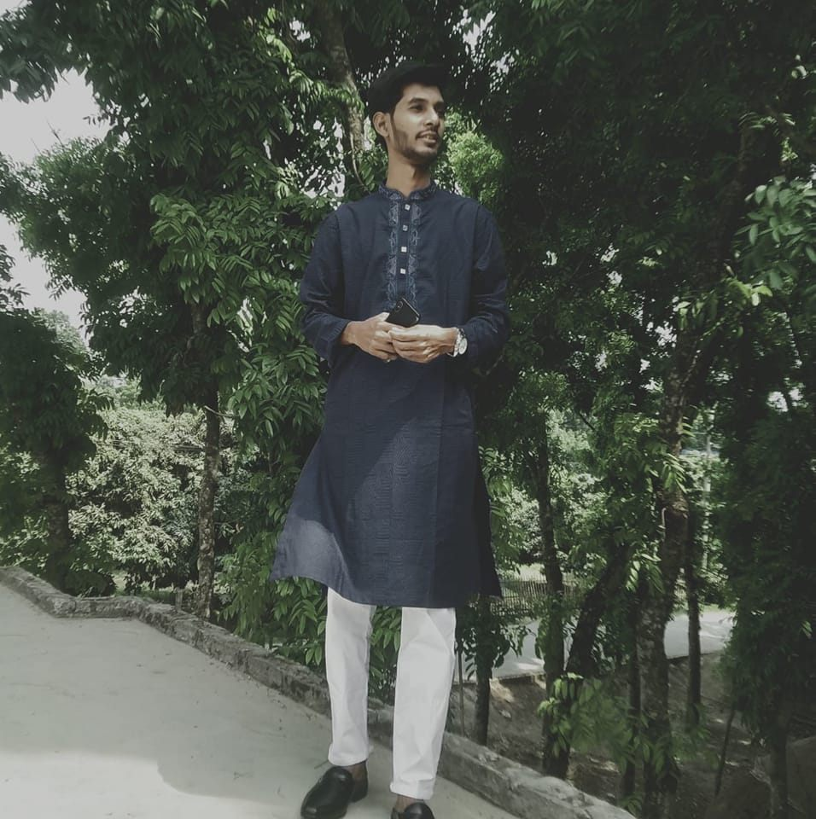

**Name**: M. Joy Hossain bhai

**District**: Pabna

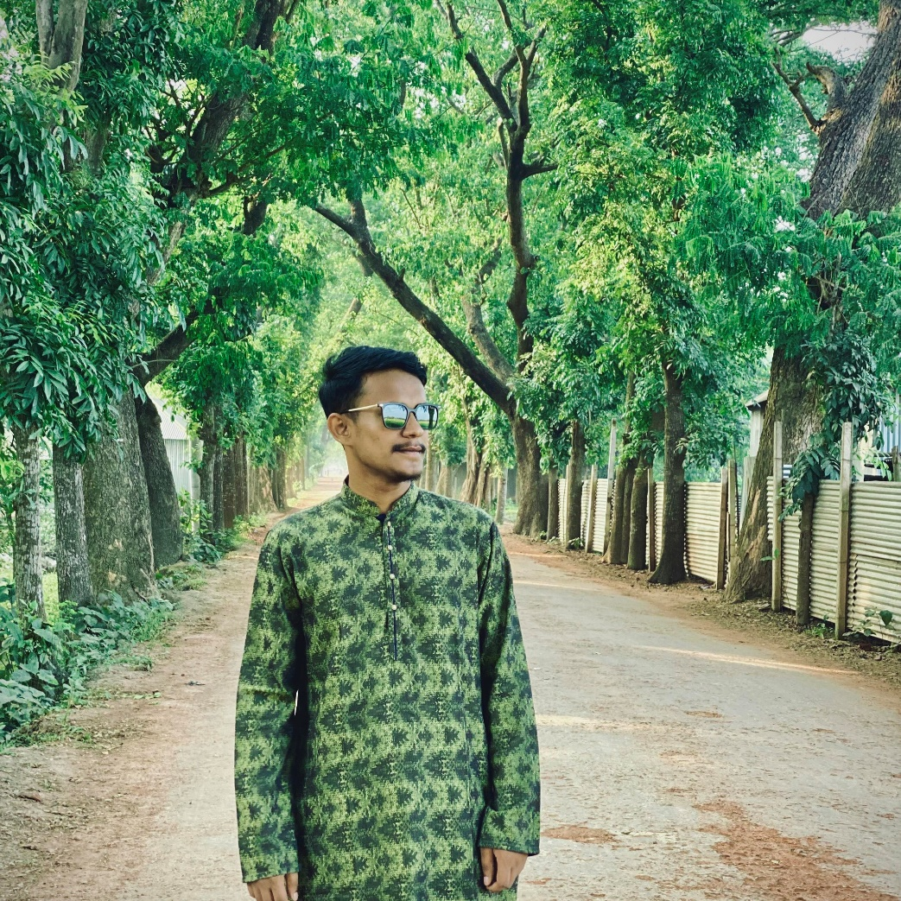

**Name**: Sajid Jahan Tofayel bhai

**District**: Mymensingh

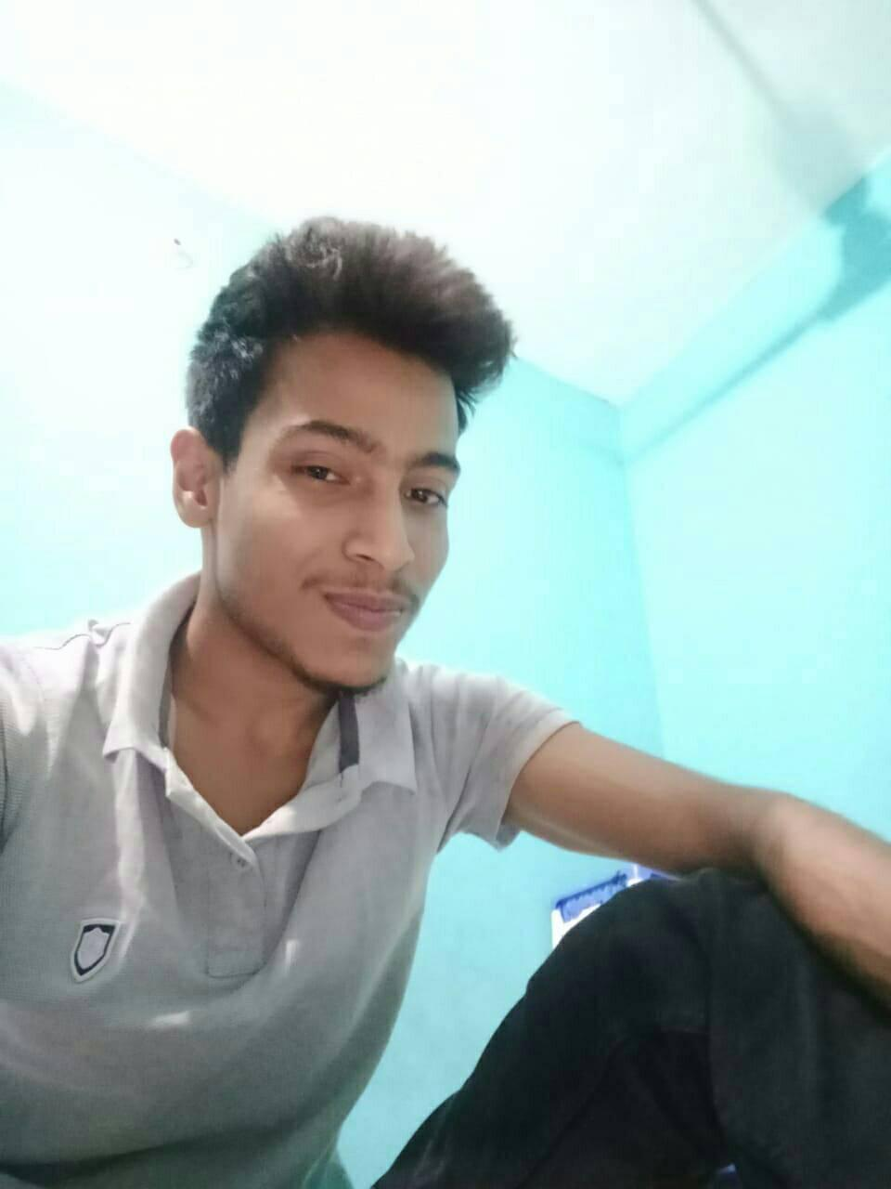

**Name**: Ashraful Alam Ridoy bhai

**District**: Kishoreganj

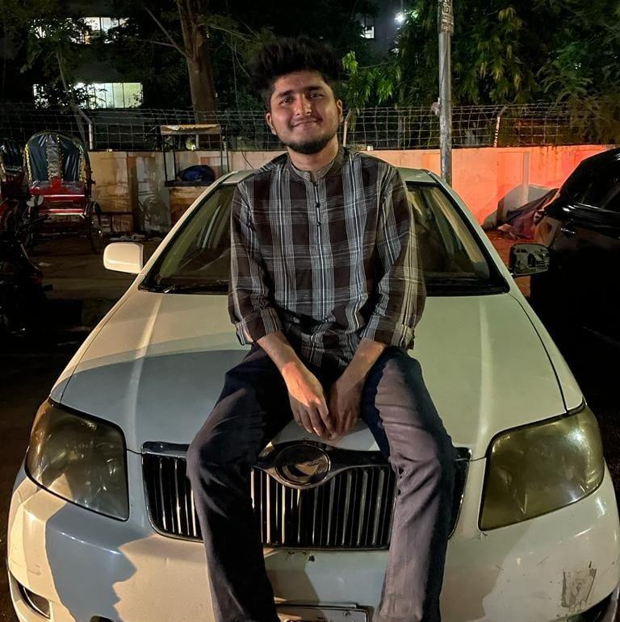

**Name**: Anas Bin Shabbir bhai

**District**: Dhaka

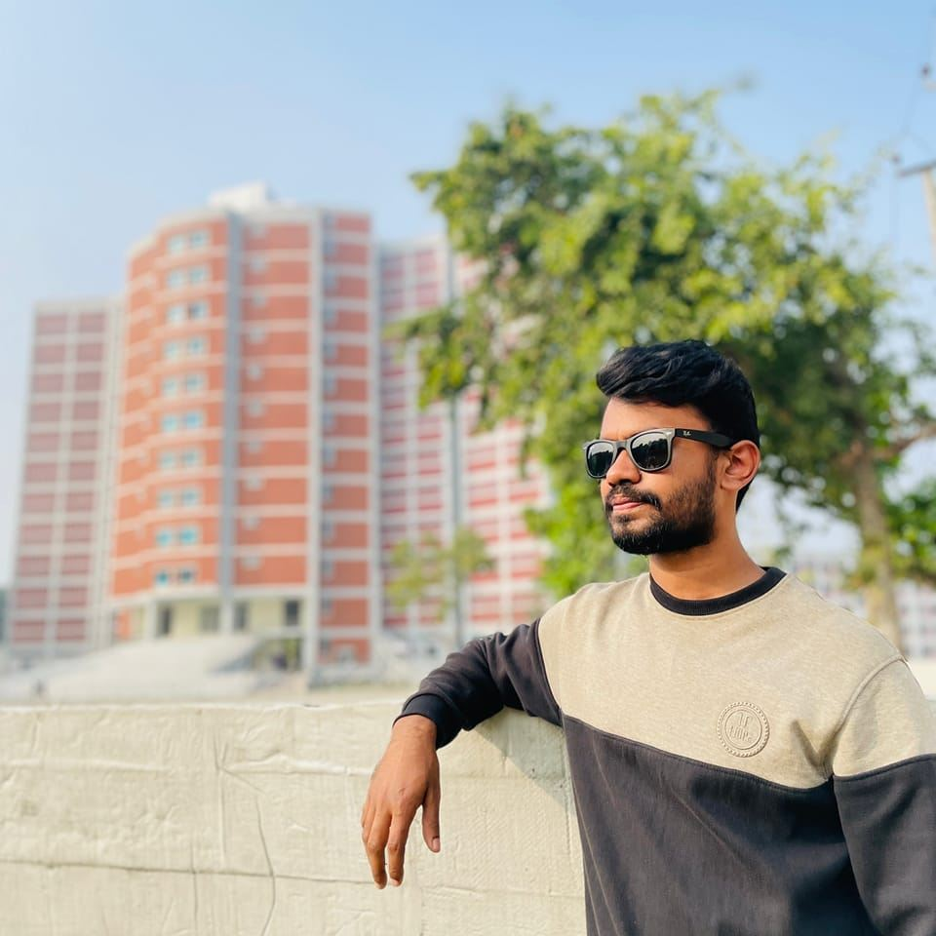

**Name**: Mahmudul Hasan Matin bhai

**District**: Tangail

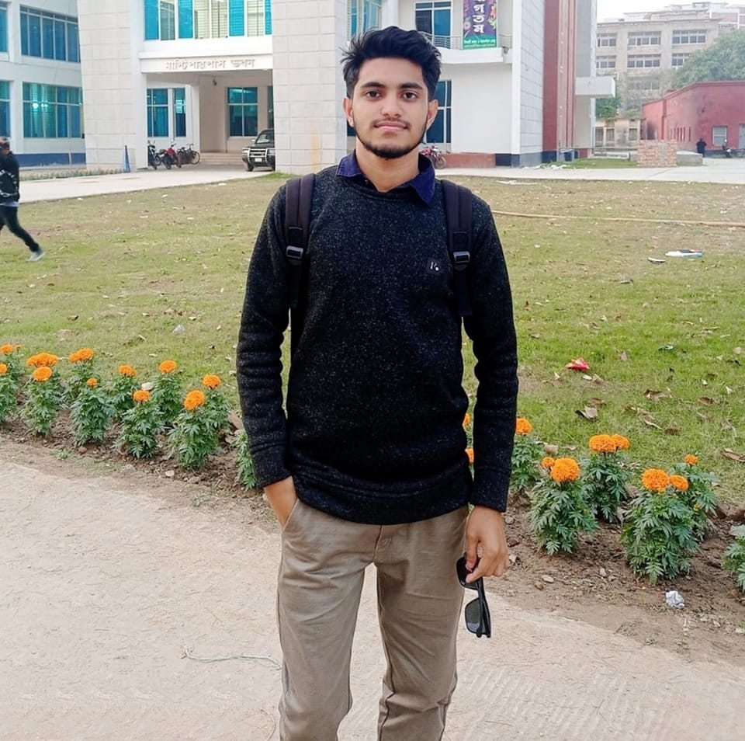

**Name**: Md. Emon Hasan bhai

**District**: Kishoreganj

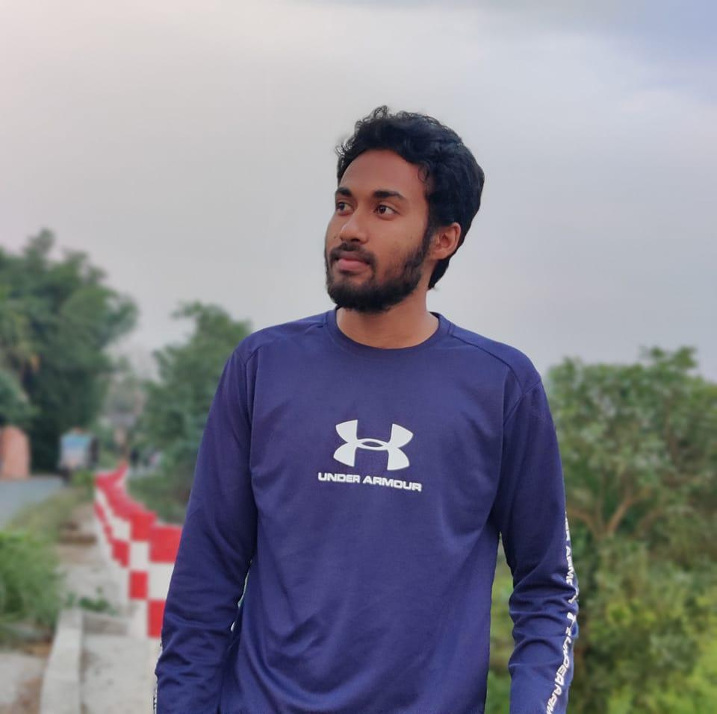

**Name**: Md Shakil Khan bhai

**District**: Manikganj

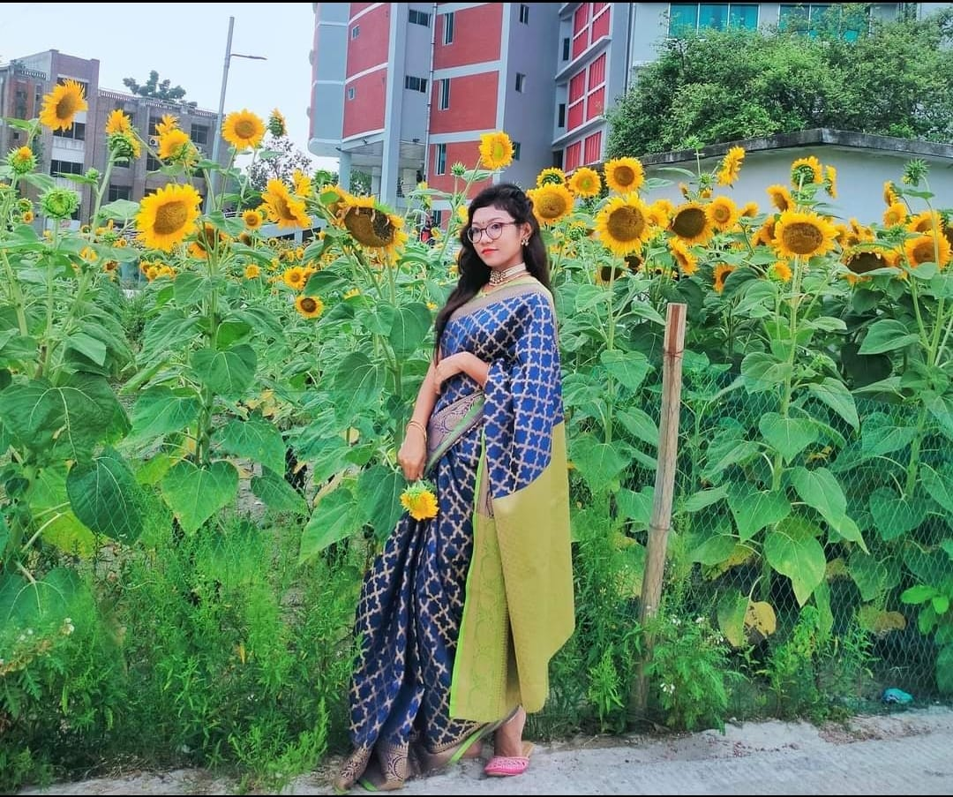

**Name**: Mukta Barman apu

**District**: Gazipur

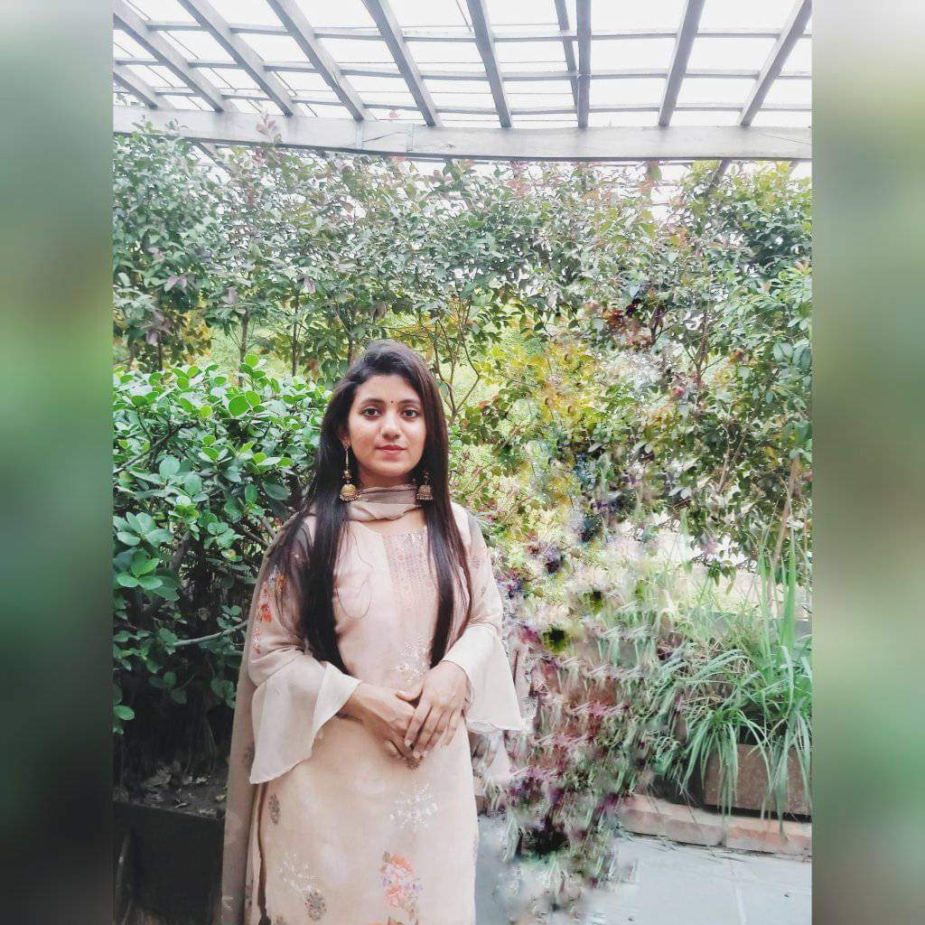

**Name**: Farzana Yeasmin Era apu

**District**: Gazipur

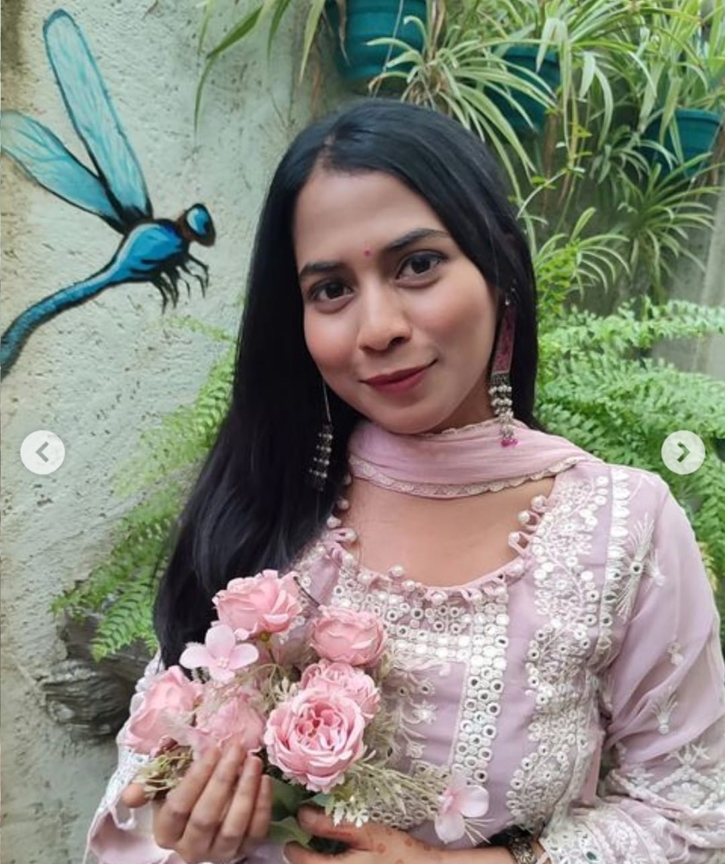

**Name**: Sanjida Akter Sompa apu

**District**: Narayanganj

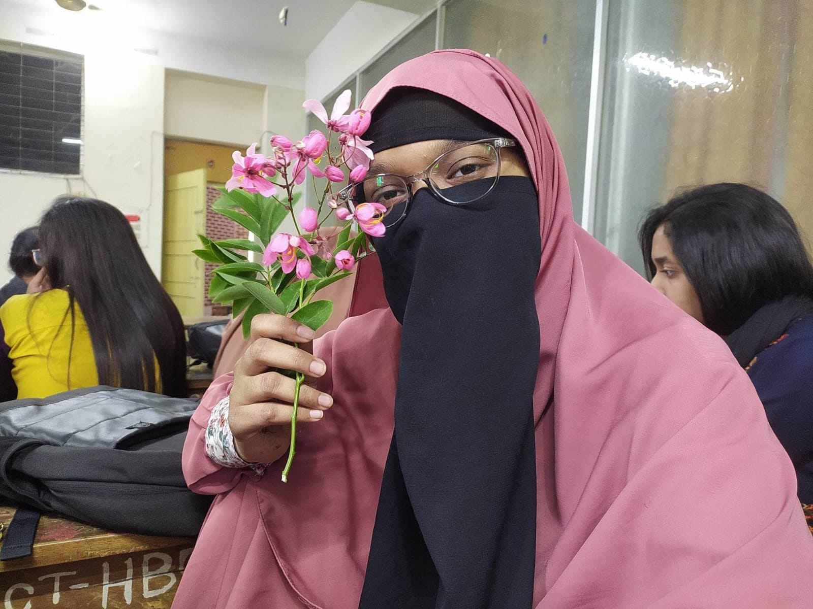

**Name**: Sadia Chowdhury apu

**District**: Tangail

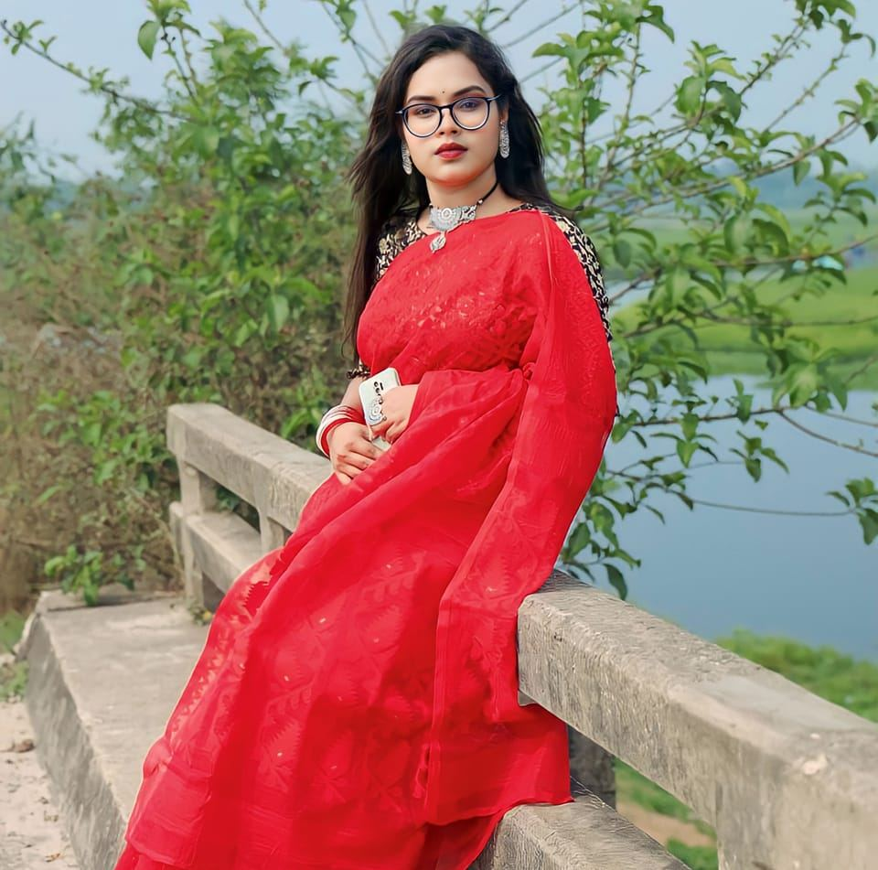

**Name**: Shetu Saha apu

**District**: Gazipur

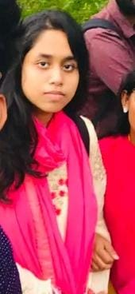

**Name**: Shusmita Ghosh Shoili apu

**District**: Manikganj



**Name**: Nowshin Tabassum Dola apu

**District**: Dhaka

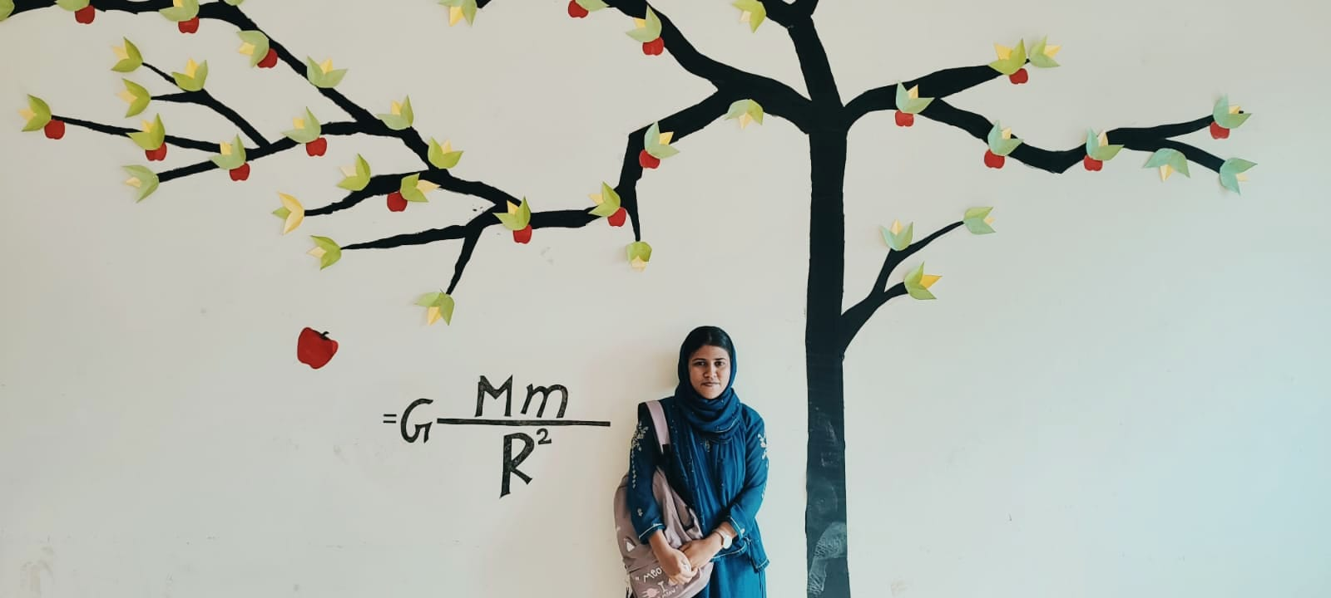

**Name**: Tafhimul Afifa apu

**District**: Chittagong

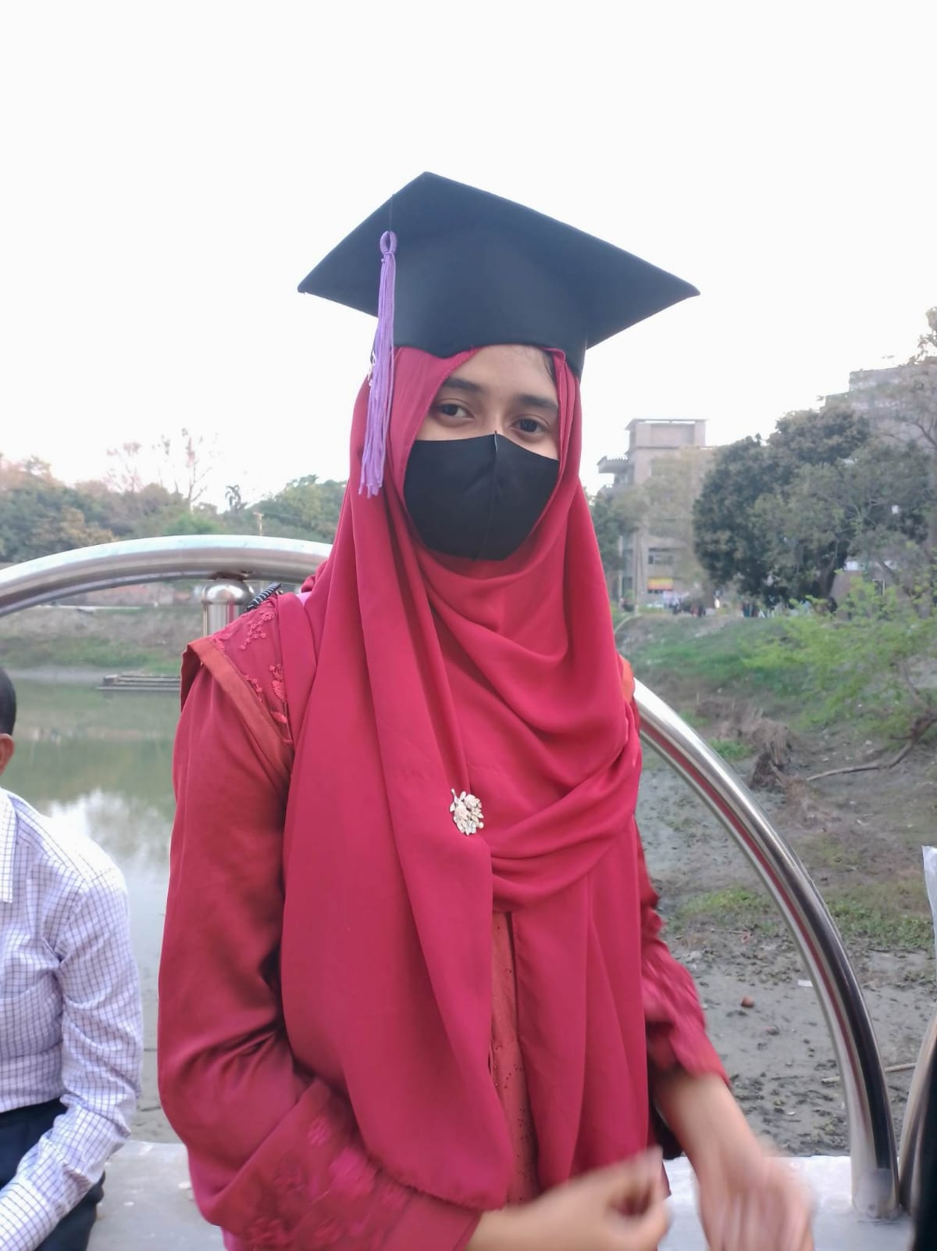

**Name**: Nusrat Jahan Bindu apu

**District**: Jamalpur

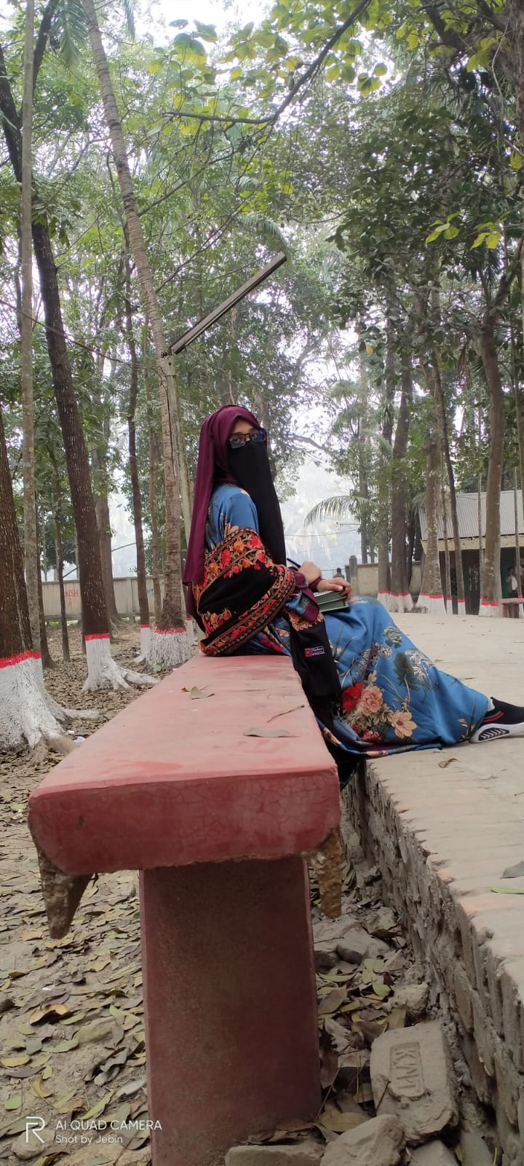

**Name**: Abida Sultana apu

**District**: Jamalpur

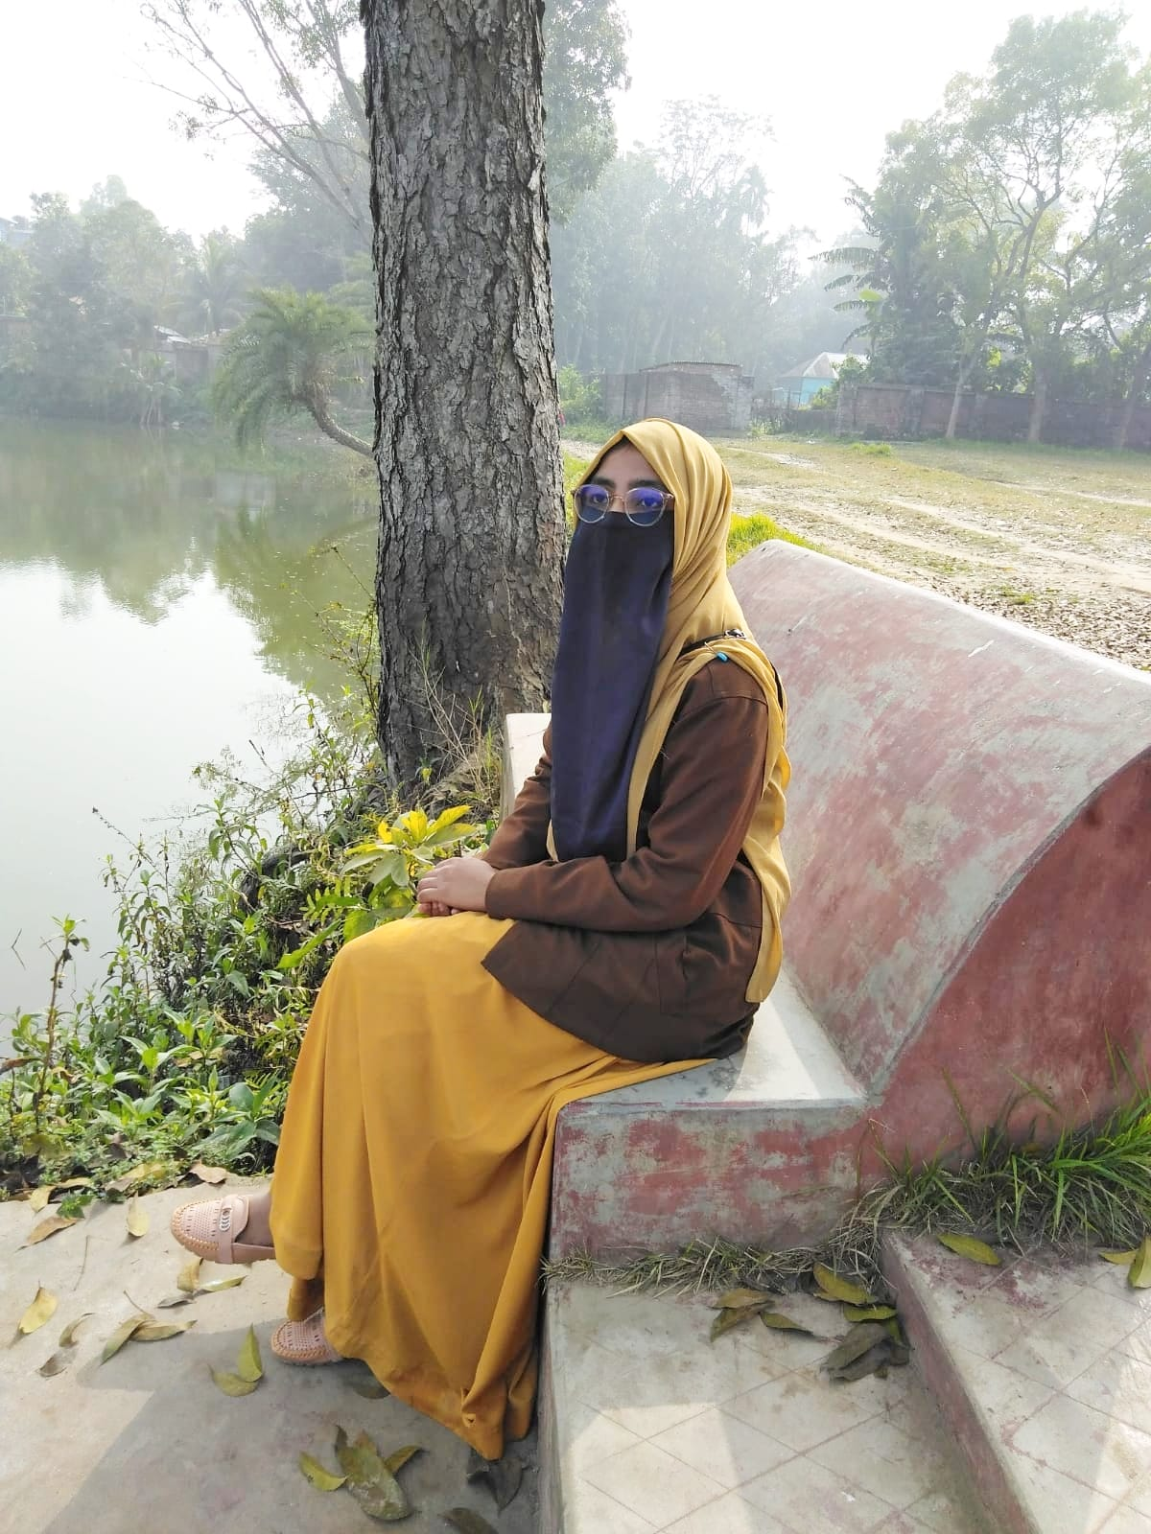

**Name**: Jebin Akter Tithi apu

**District**: Sherpur

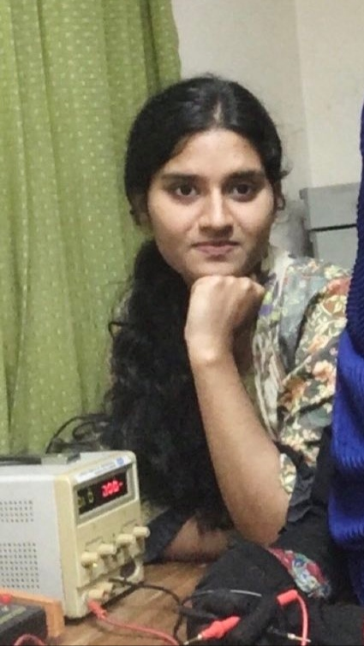

**Name**: Iffat Jahan Nilima apu

**District**: Tangail

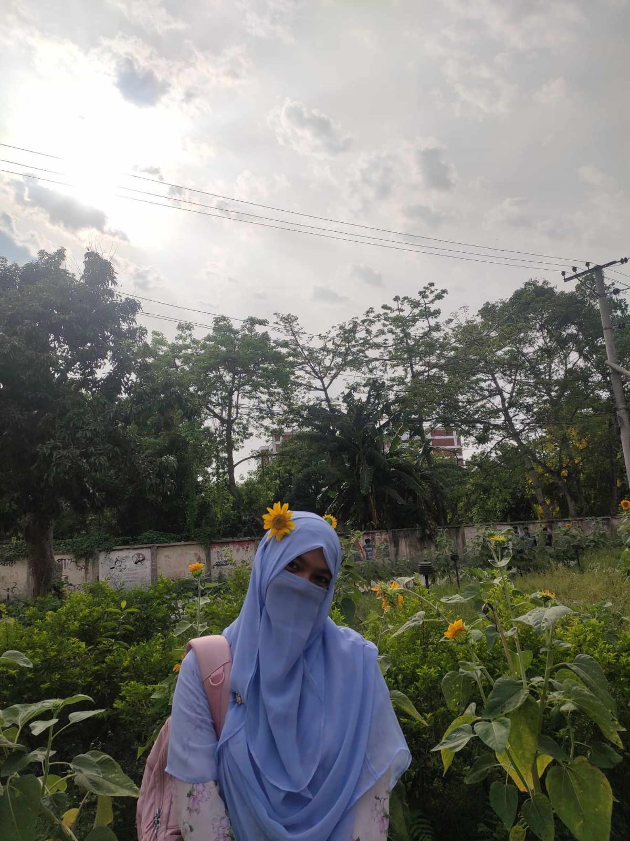

**Name**: Afsana Akter Mitu apu

**District**: Tangail

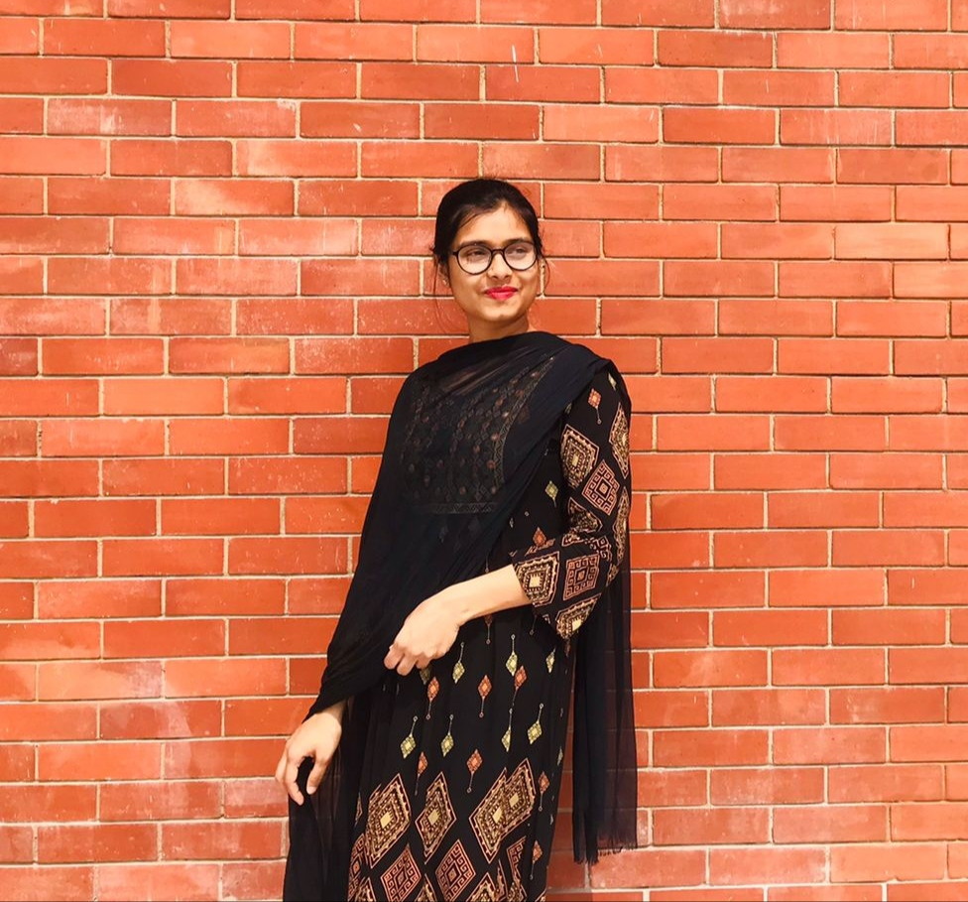

**Name**: Jerin Asha apu

**District**: Tangail

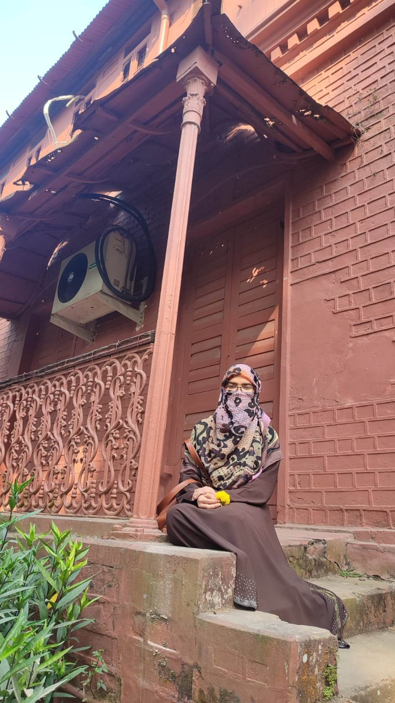

**Name**: Umma Kulsum apu

**District**: Chapainawabganj

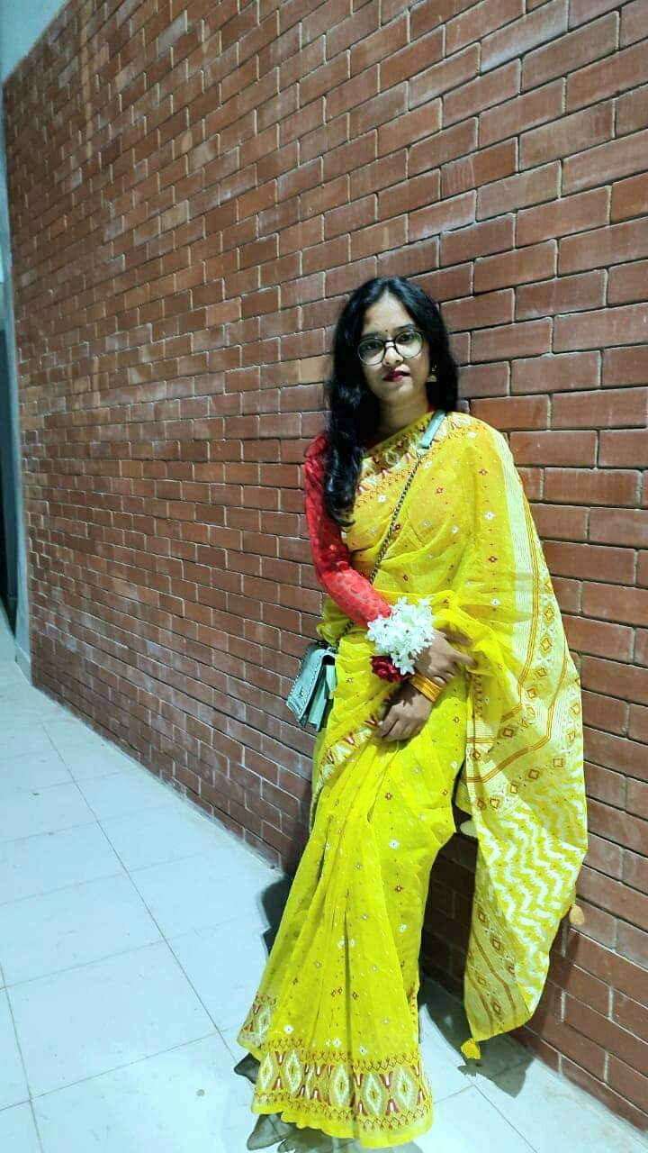

**Name**: Tanzina Fatema apu

**District**: Tangail

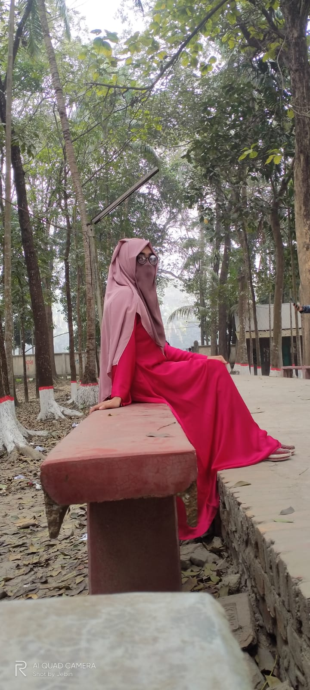

**Name**: Somaya Jannat apu

**District**: Sherpur



**Name**: Afsana Akter Mim apu

**District**: Tangail

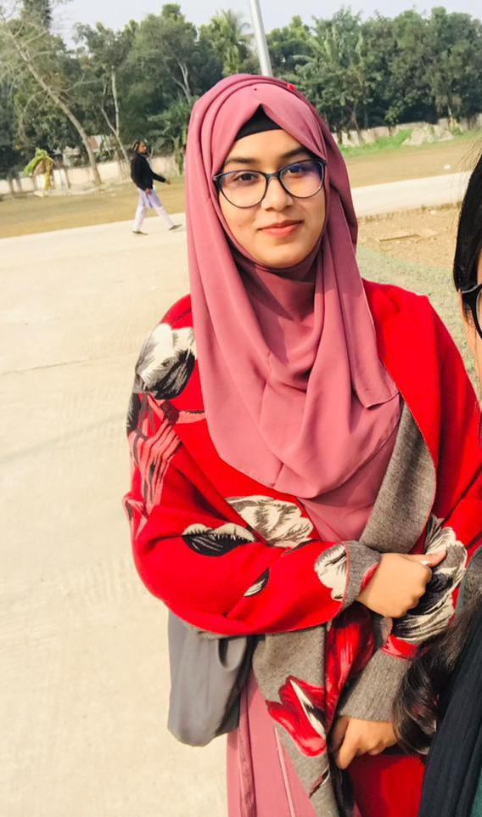

**Name**: Ishrat Jahan Ema Khan apu

**District**: Tangail

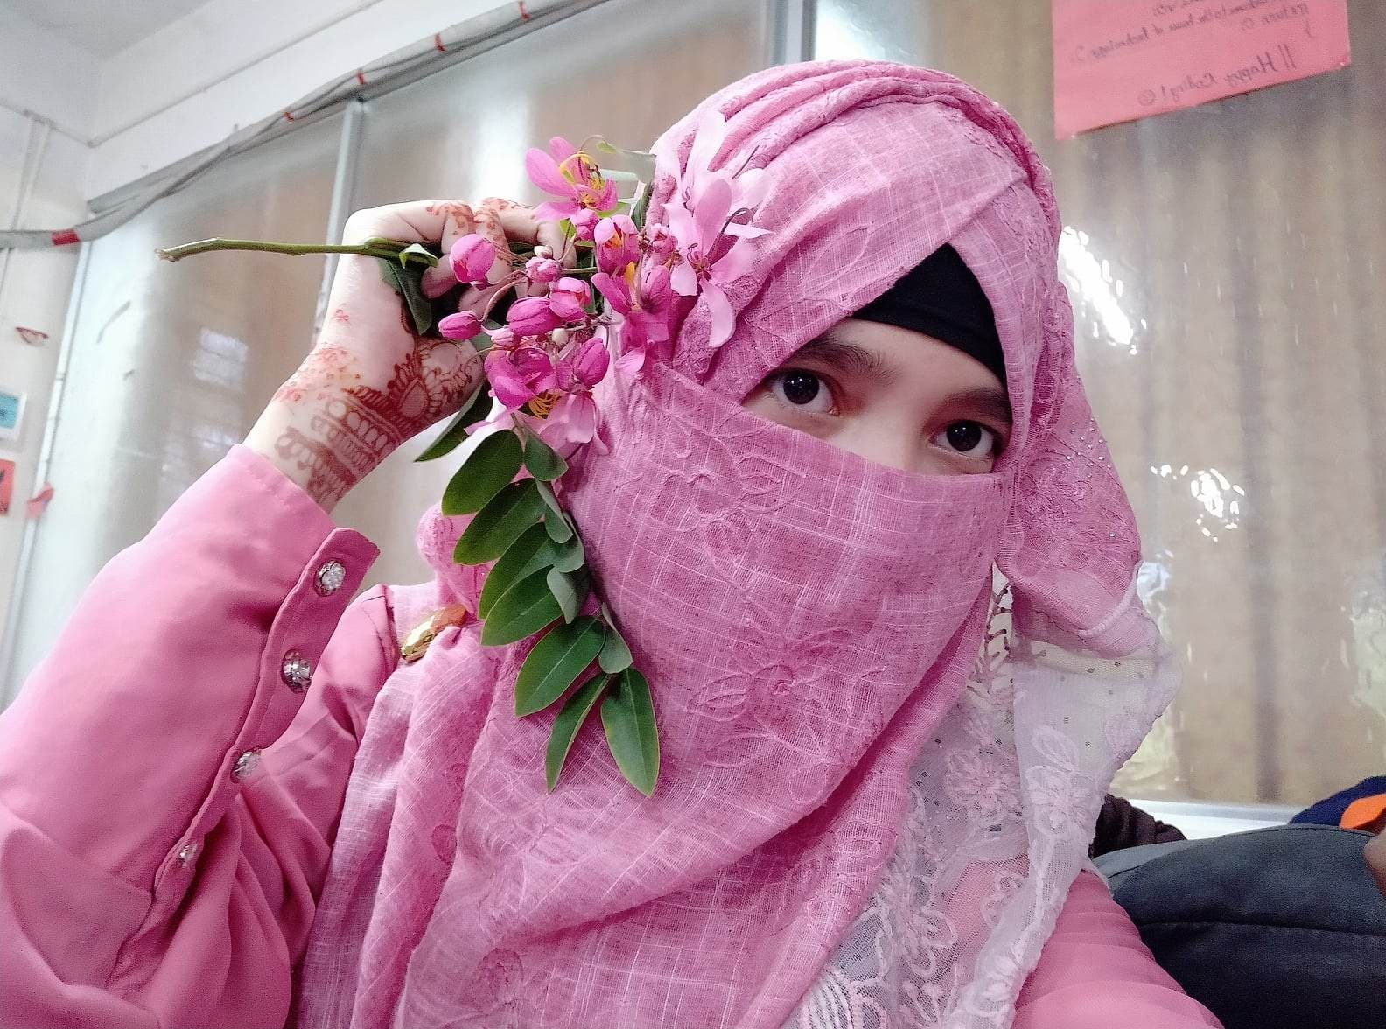

**Name**: Khadija Arifin Meem apu

**District**: Gazipur